**DTT Deployment Instructions**

**Summary**

1. Get the release bundle folder ‘swpdttp6’ (offline) from the Development team.
2. Copy the release bundle folder ‘swpdttp6’ to Server location which serves as a placeholder for the release bundle.
3. Using MS SQL Studio execute the DTT database scripts to create the database entities i.e. DTT tables. The data script file ‘DTTScripts.sql’ is available at location ‘swpdttp6\dbscripts’
4. Customize the P6 Webservices Configuration for web services security.
5. Create a domain ‘SWPDTTP6’ using weblogic configuration wizard.
6. Edit startWeblogic.cmd file
7. Start weblogic server
8. Create a Data source with name ‘ DTTConnectionDS’
9. Copy the ‘swpdttp6’ from Server location (Step2) to ‘D:\Oracle\Middleware\user_projects\domains\SWPDTTP6’ . **If this step is successful then skip steps 9**
10. Create folders and transfer files:
    1. Create folder ‘swpdttp6’ under ‘D:\Oracle\Middleware\user_projects\domains\SWPDTTP6’
    2. Create folder ‘dbscripts’,’ config’,’logs’ under ‘D:\Oracle\Middleware\user_projects\domains\SWPDTTP6\ swpdttp6’
    3. Transfer SWPDTTP6.war file to server folder location ‘D:\Oracle\Middleware\user_projects\domains\SWPDTTP6\swpdttp6\’
    4. Transfer database scripts file ‘DTTScripts.sql’ to server folder location D:\Oracle\Middleware\user_projects\domains\ SWPDTTP6\swpdttp6\dbscripts\
    5. Transfer DTT.properties to server folder location D:\Oracle\Middleware\user_projects\domains\ SWPDTTP6\swpdttp6\config\
11. Create a Windows Scheduled Task to start the weblogic server
12. Edit the DTT.properties file with required changes appropriately
13. Deploy the SWPDTTP6.war using weblogic console
14. Open the log file at location 'D:\Oracle\Middleware\user_projects\domains\ SWPDTTP6\swpdttp6\logs\swpdttp6.log'
15. Transfer the input excel data file received by Business to the location D:\Oracle\Middleware\user_projects\domains\ SWPDTTP6\swpdttp6\config\
16. Undeploy and Redeploy the SWPDTTP6.war
17. Open the log file at location 'D:\Oracle\Middleware\user_projects\domains\ SWPDTTP6\swpdttp6\logs\swpdttp6.log' ,it should start logging FLTP Solution messages.

**Details**

1. **Get the release bundle folder ‘swpdttp6’ (offline) from the Development team**
   1. Get the location of the release bundle offline from the development team
2. **Copy the release bundle folder ‘swpdttp6’ to Server location which serves as a placeholder for the release bundle.**
   1. The placeholder Server location can be any folder to which the installer has write access.
3. **Using MS SQL Studio execute the DTT database scripts to create the database entities i.e. DTT tables. The data scripts are available at location ‘D:\Oracle\Middleware\user_projects\domains\ SWPDTTP6\swpdttp6\dbscripts’**

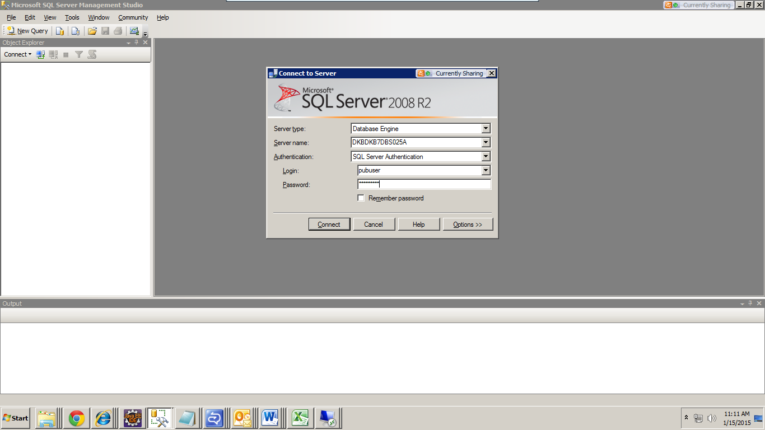  
Login to the database using Microsoft SQL Server Management Studio with following properties:

* Server Name: DKBDKB7DBS025A
* UserName: <<database user name>>
* Password: <<database password>>

Click Connect.

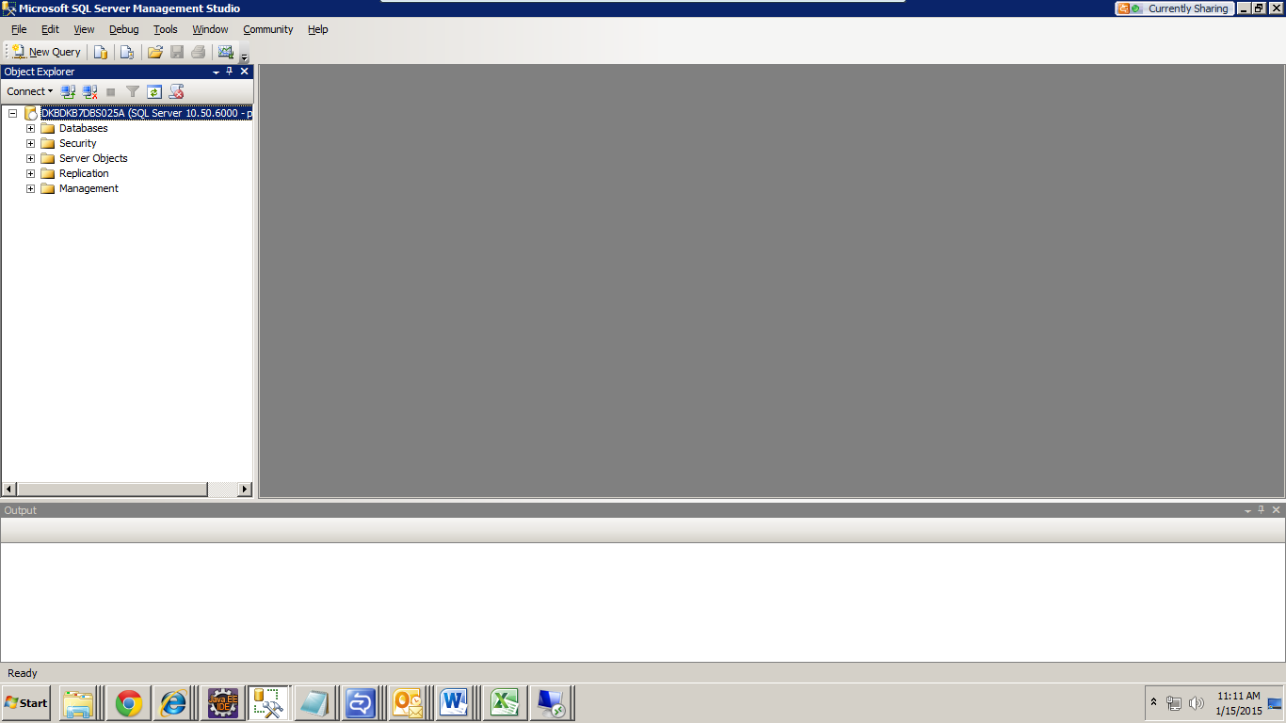

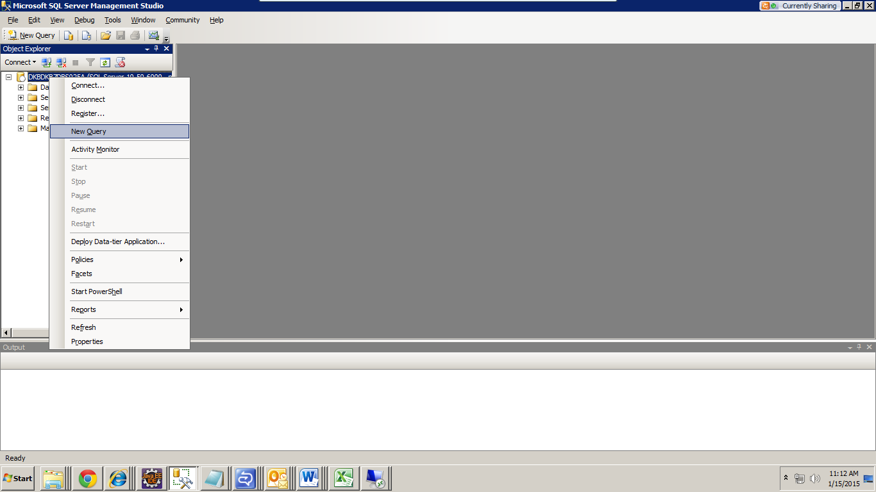

Copy the script from the ‘DTTScripts.sql’ file on to the new query window and execute the scripts.

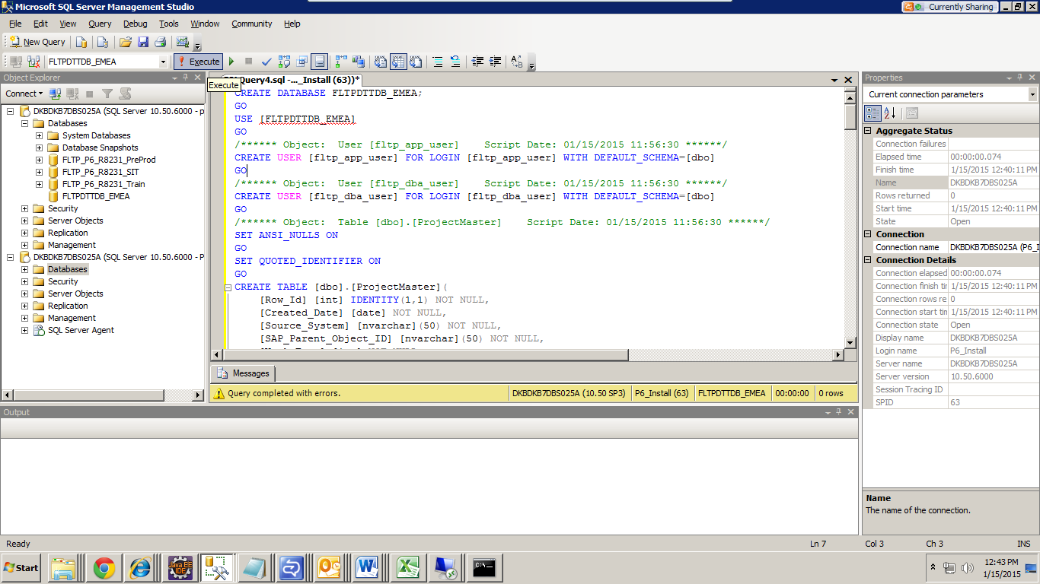

1. **Customize the P6 Webservices Configuration for web services security.**

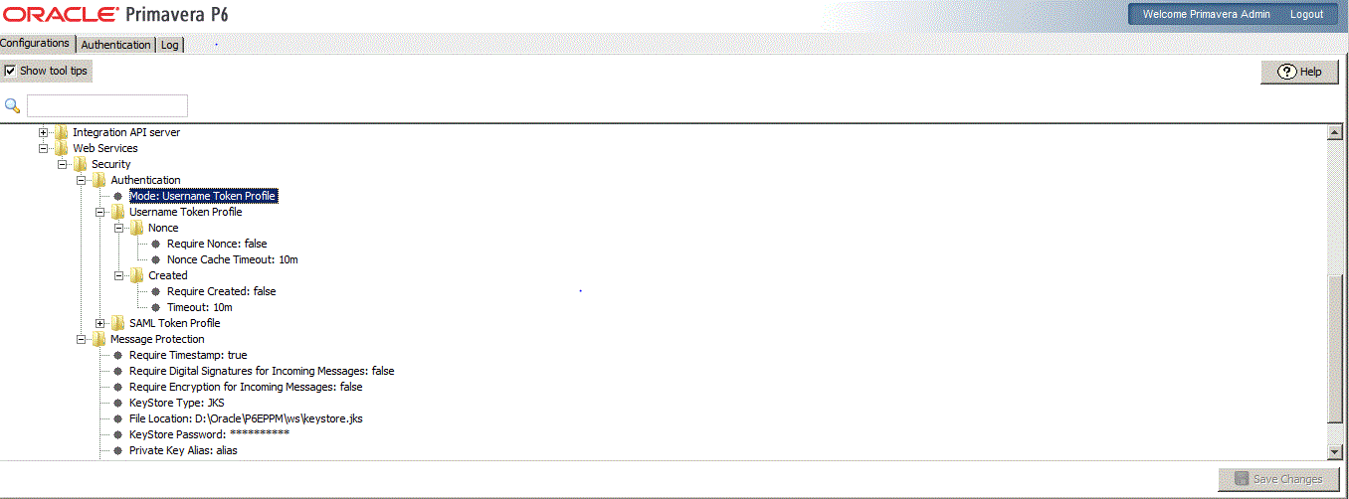

1. As shown make the all the webservices security parameters to ‘false’
2. SAVE CHANGES.
3. Do the same for the Factory Settings webservices node also.
4. Restart the webservices server and P6 Webserver
5. **Create a domain ‘SWPDTTP6’ using weblogic configuration wizard**

Go to :

* Start menu of windows, locate the software Oracle Weblogic.
* Locate and click the menu Weblogic Server 11g R1 -> Tools >Configuration Wizard

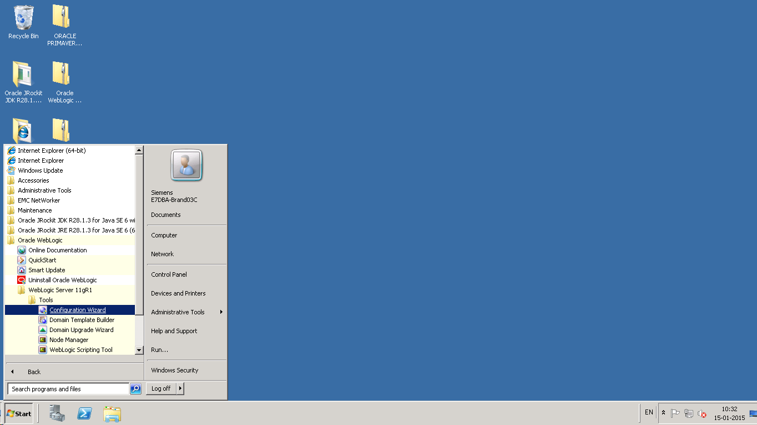

Select Create a new Weblogic domain and click Next

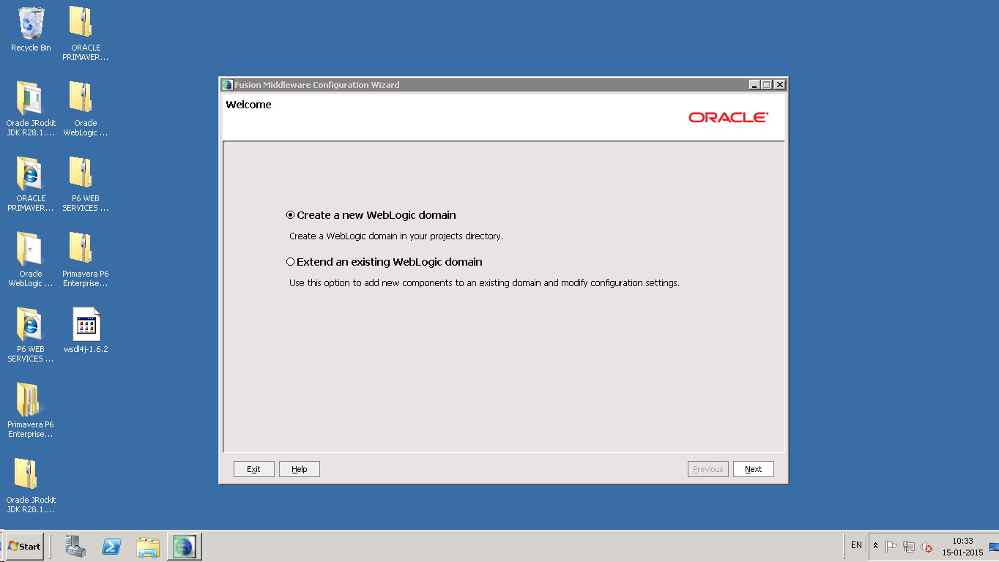

Select Option Generate a domain Configured automatically to support the following products and click Next.

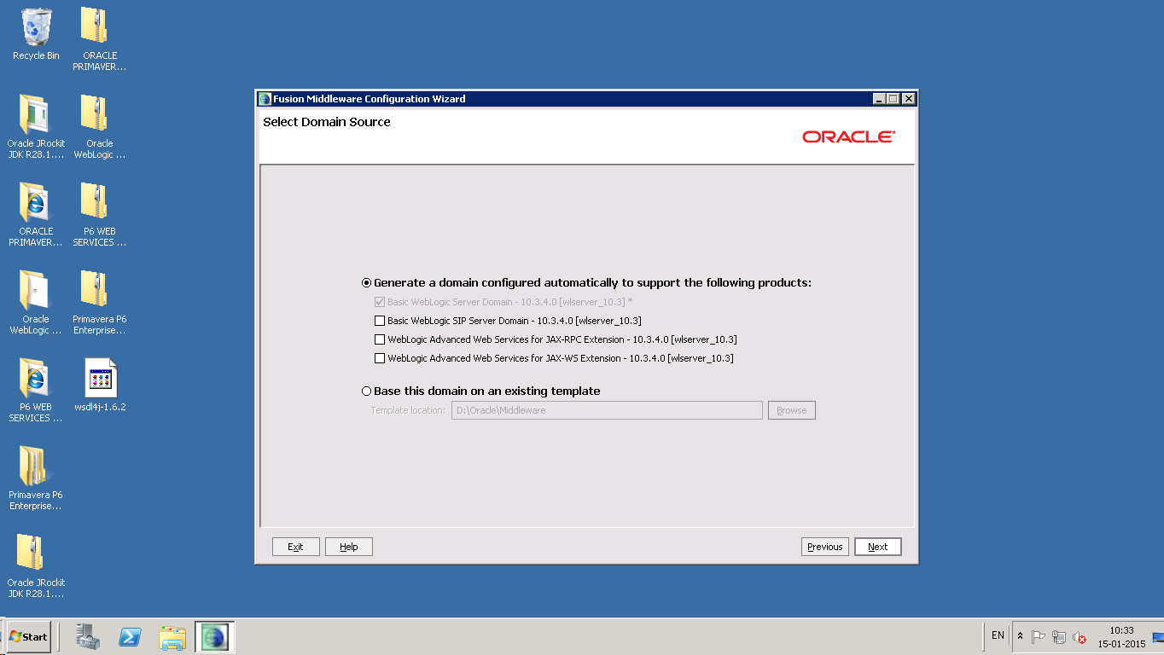

Enter Domain Name as SWPDTTP6 and click Next.

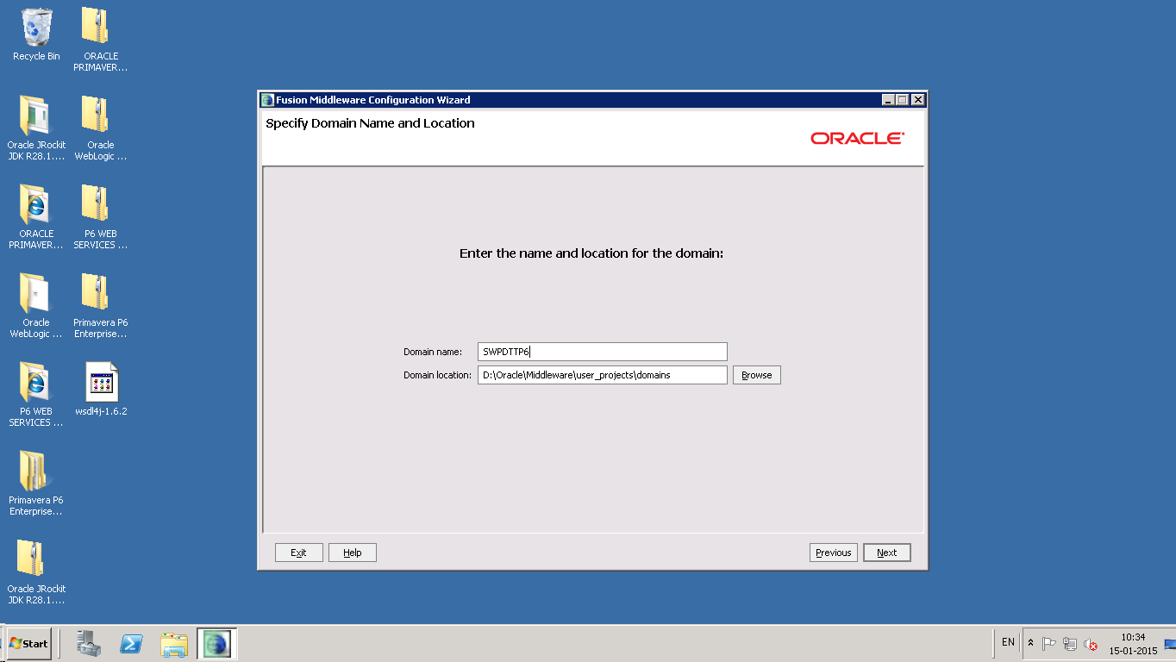

Enter following values and click Next.

* Name : weblogic

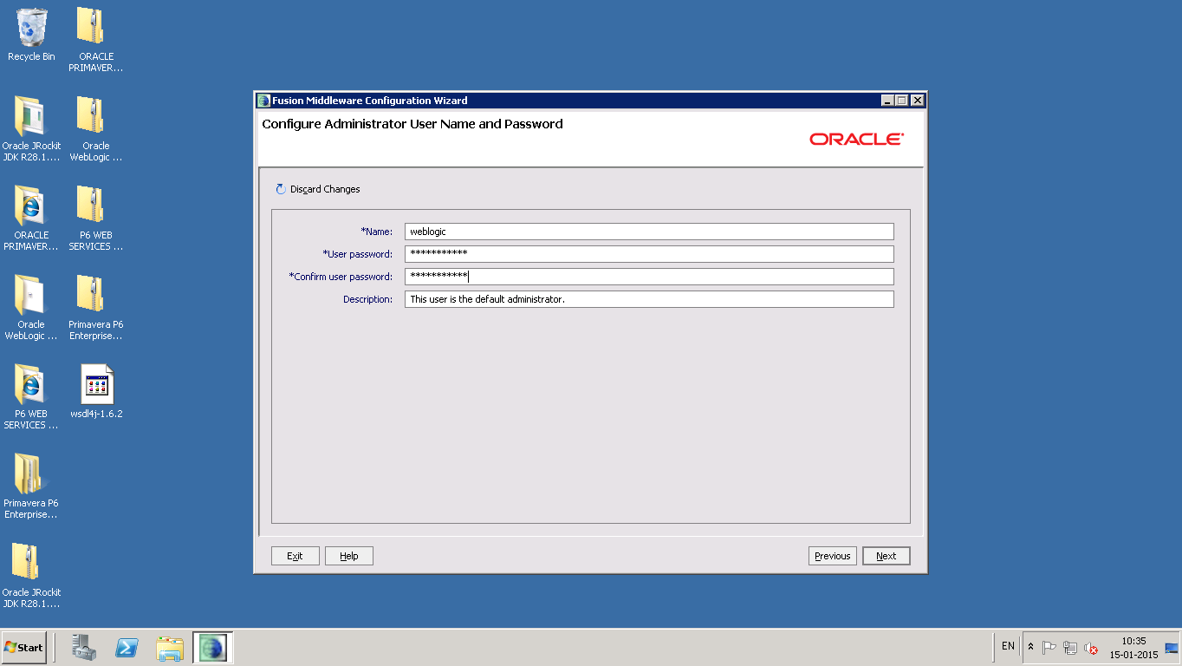

Select relevant option for mode and select option Available JDKs and select the jdk. Click Next.

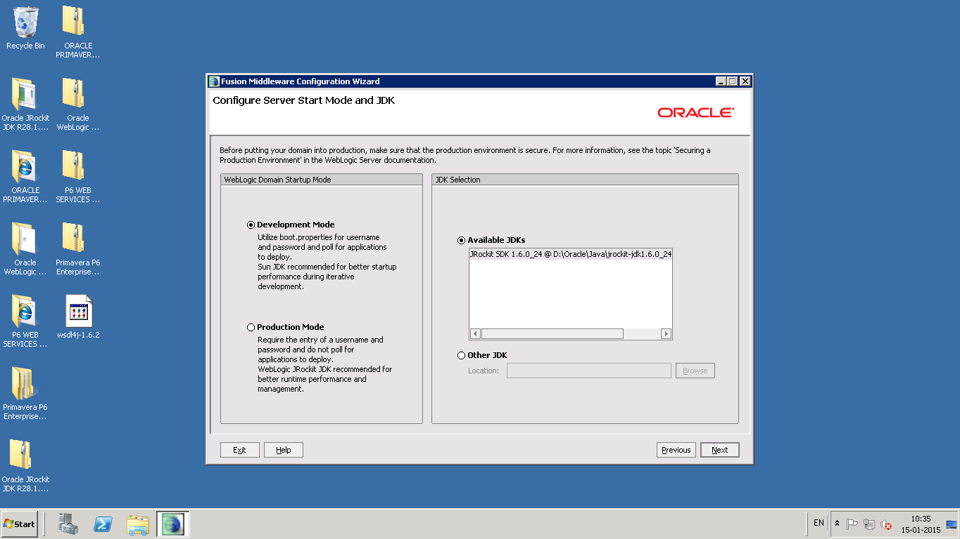

Select the option Administration Server and Click Next.

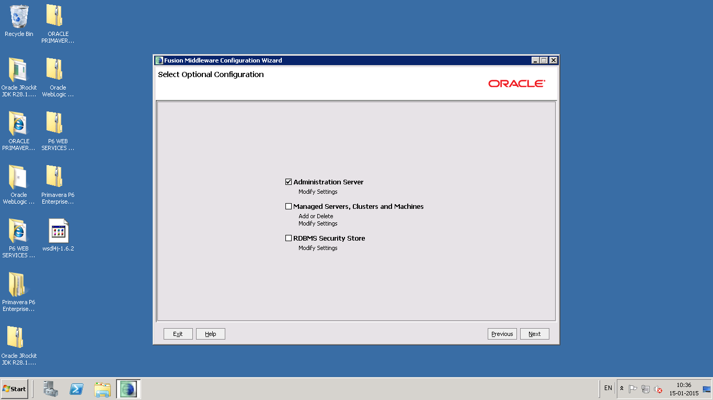

Select the option Administration Server and Click Next.

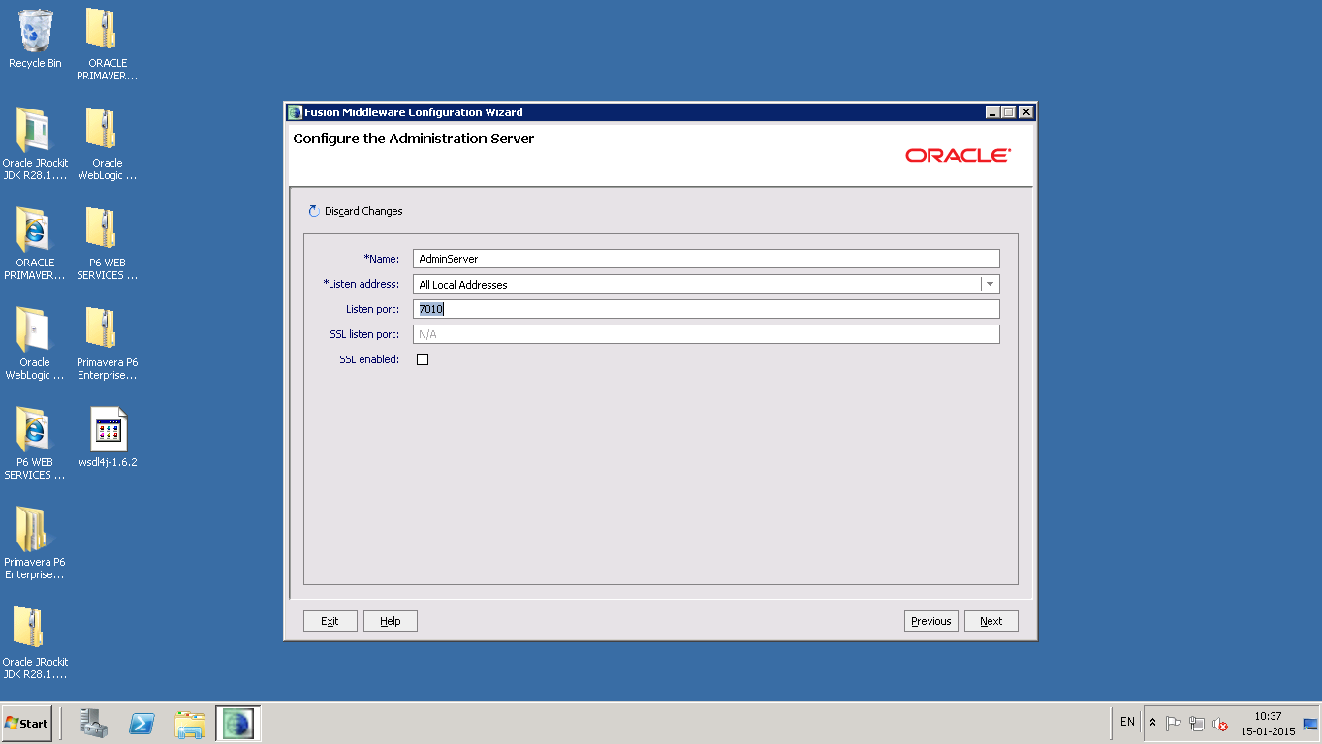

Enter Listen port field value as 7010. Click Next.

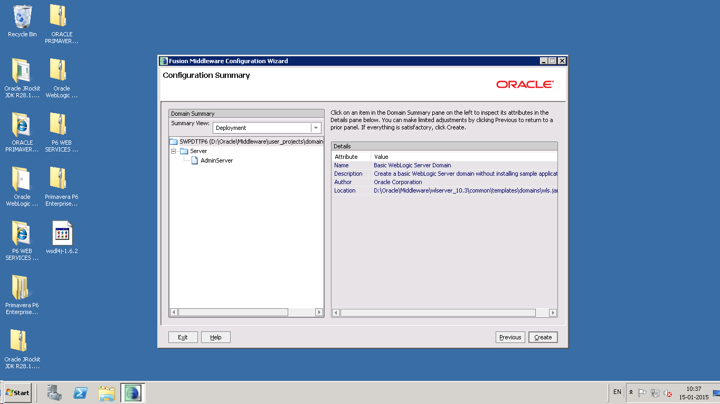

Click Create.

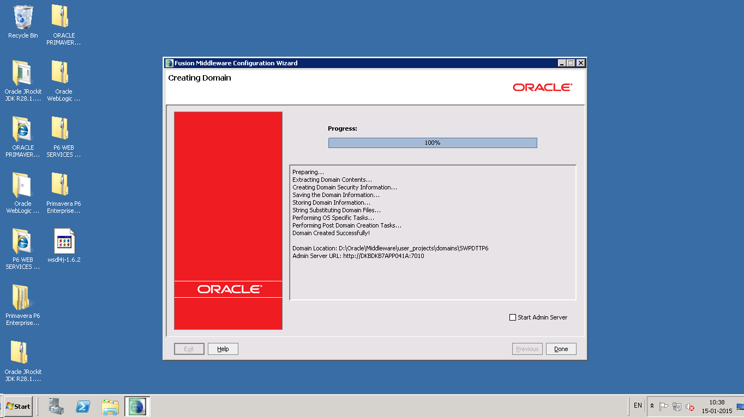Click Done.

1. **Edit startWeblogic.cmd file**

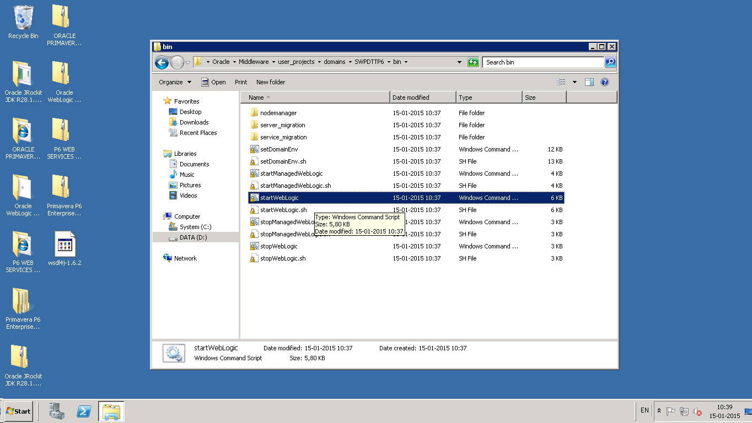

Open the startWeblogic.cmd file

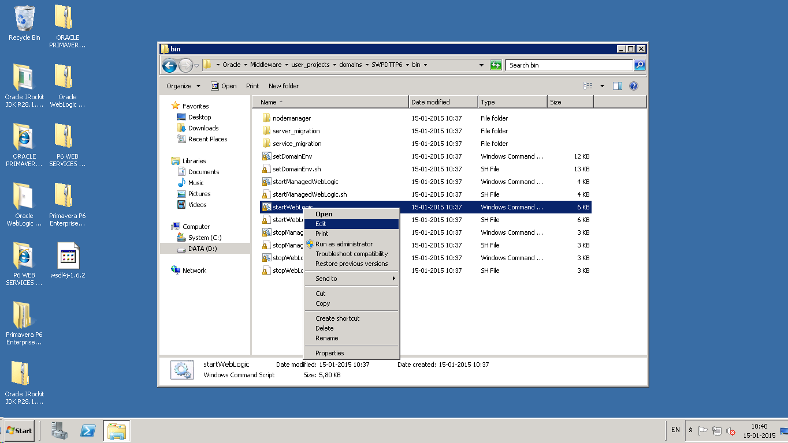

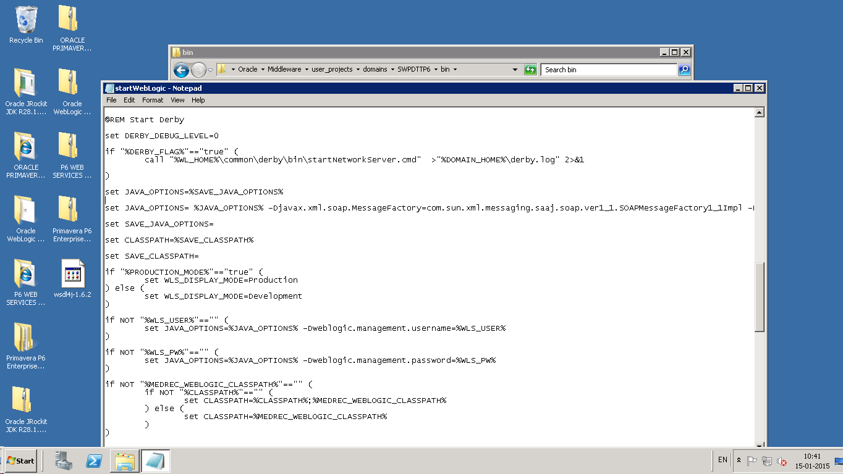

Append the JAVA_OPTIONS with

-Djavax.xml.soap.MessageFactory=com.sun.xml.messaging.saaj.soap.ver1_1.SOAPMessageFactory1_1Impl -Djavax.xml.soap.SOAPConnectionFactory=weblogic.wsee.saaj.SOAPConnectionFactoryImpl

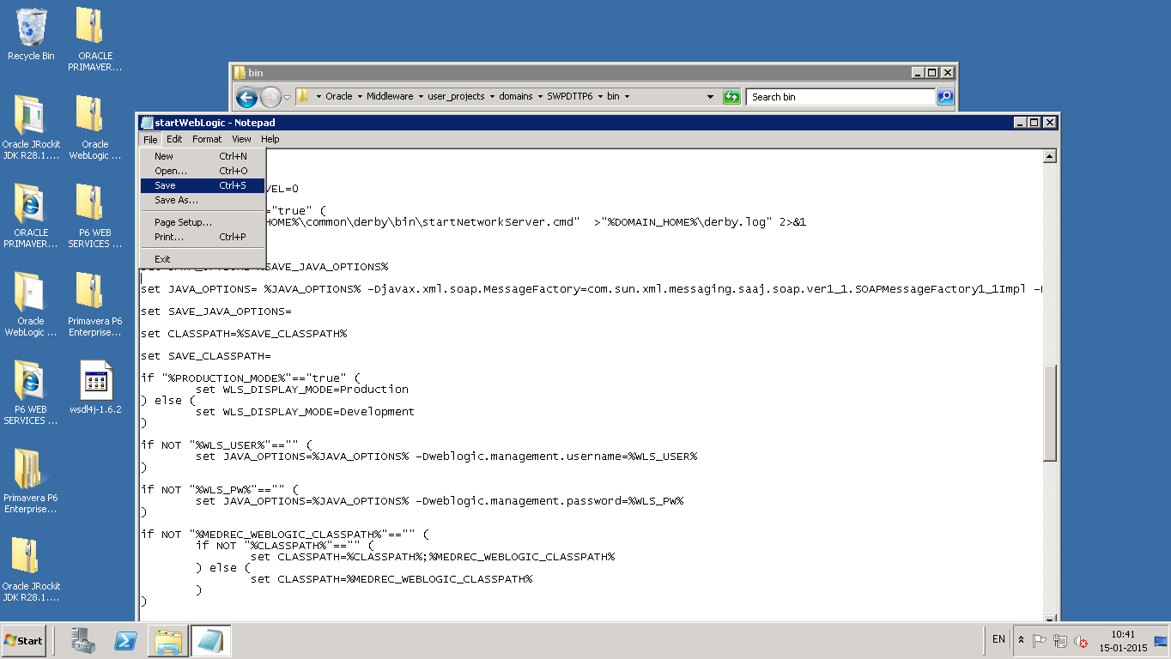

Save the file.

1. **Start weblogic server**

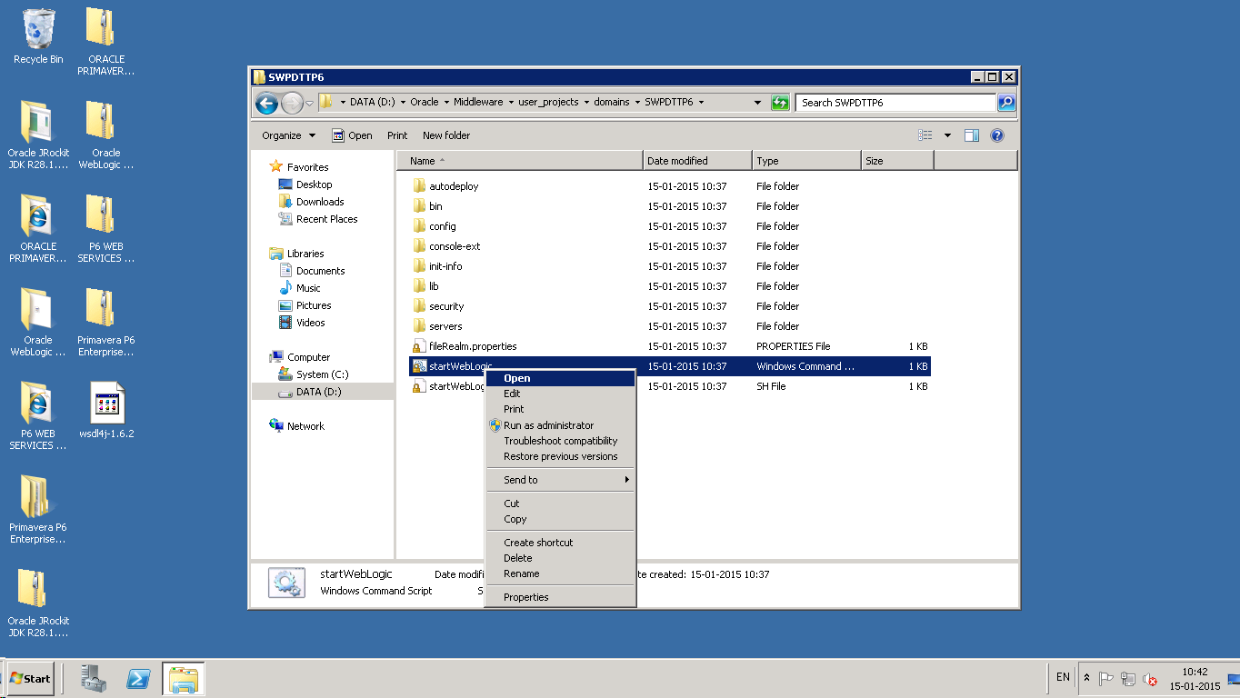

Execute the startWeblogic.cmd using command prompt

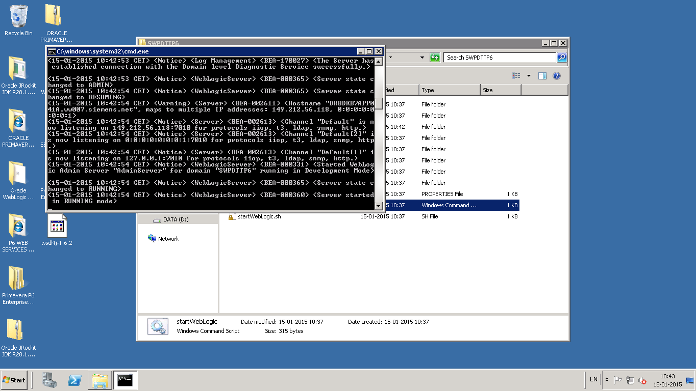

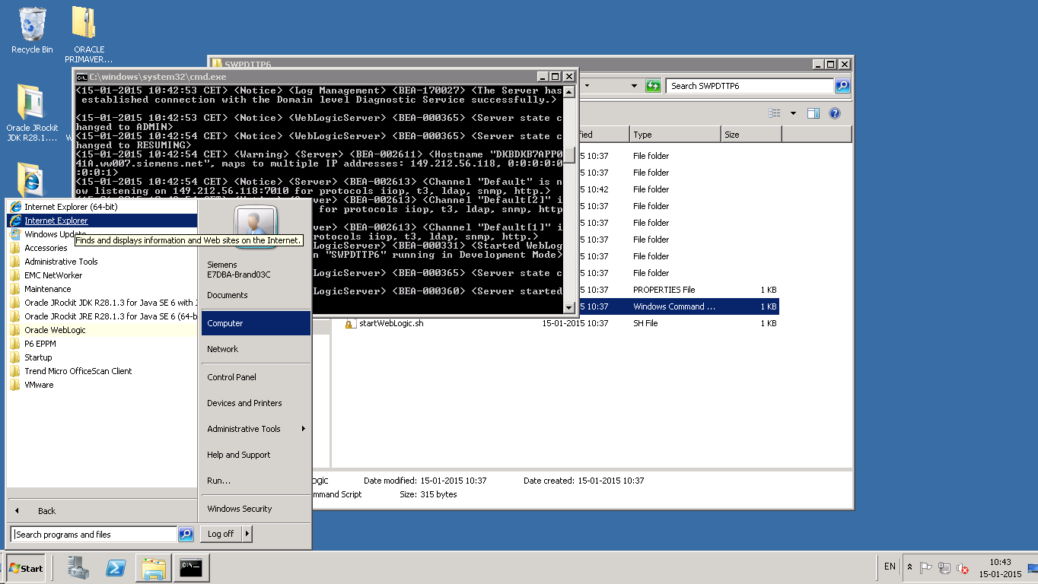

Open a browser window and type url as http://<<serverhostname>>:<<serverportno>>/console

(e.g.: http:// DKBDKB7APP041A:7010/console)

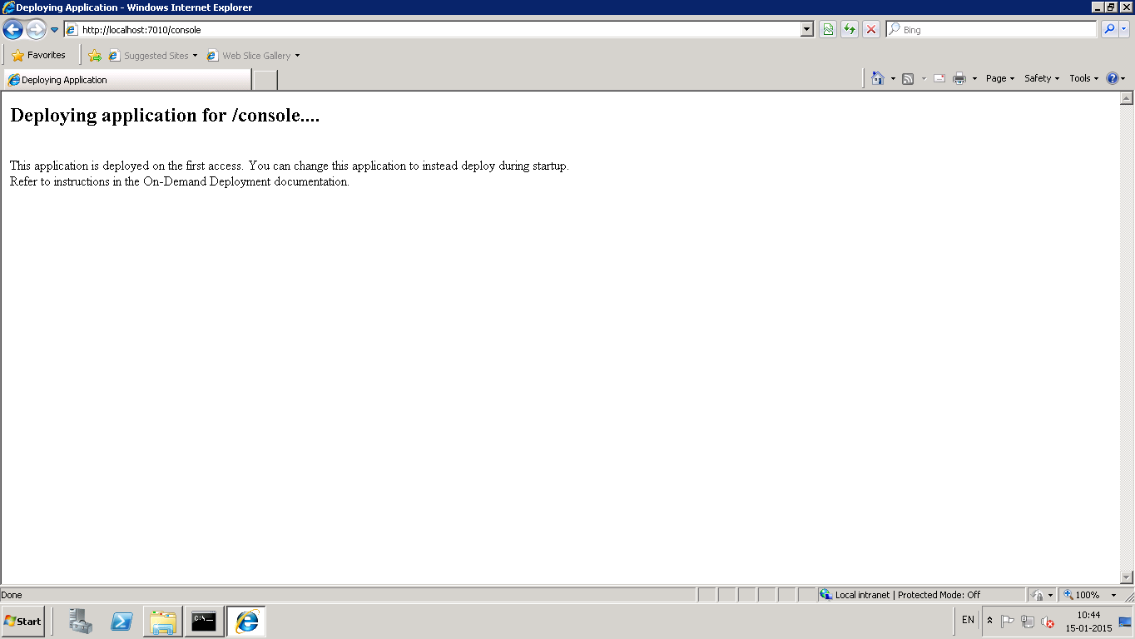

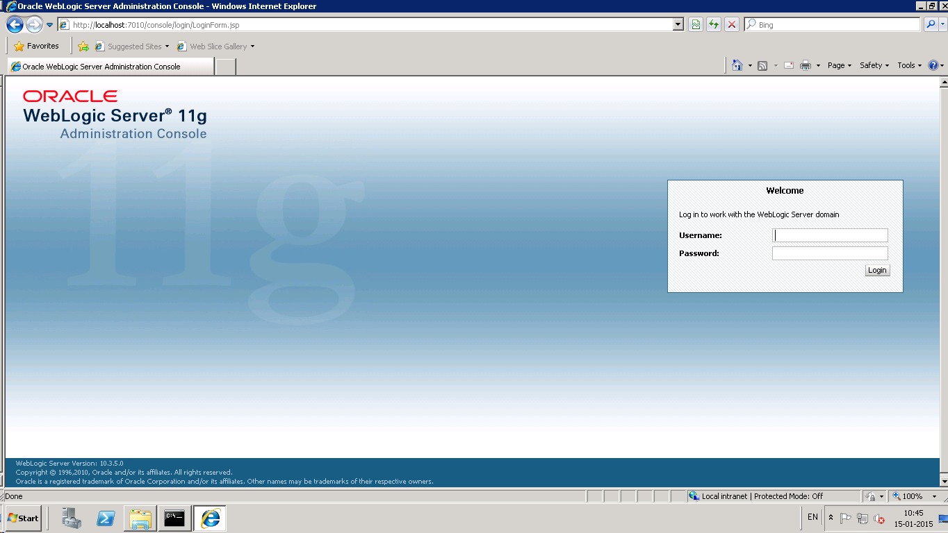

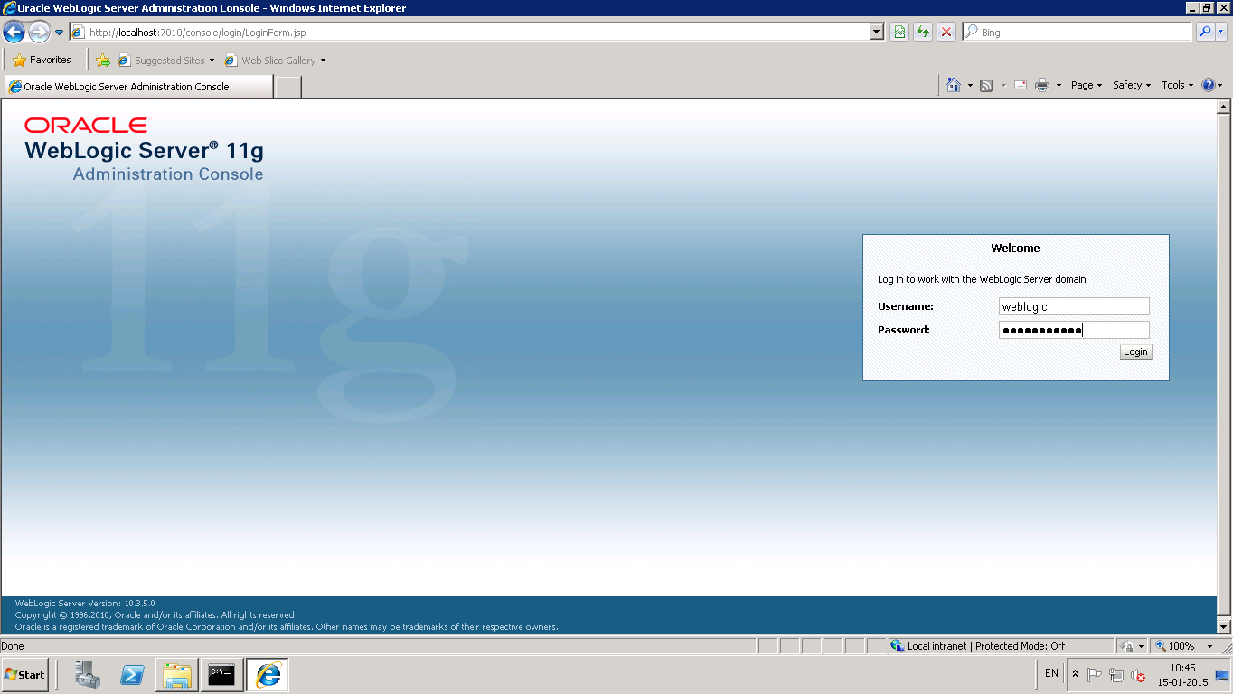

Enter the username and password given in step 4 (*Create a domain ‘SWPDTTP6’ using weblogic configuration wizard)*

1. **Create a Data source with name ‘ DTTConnectionDS’**

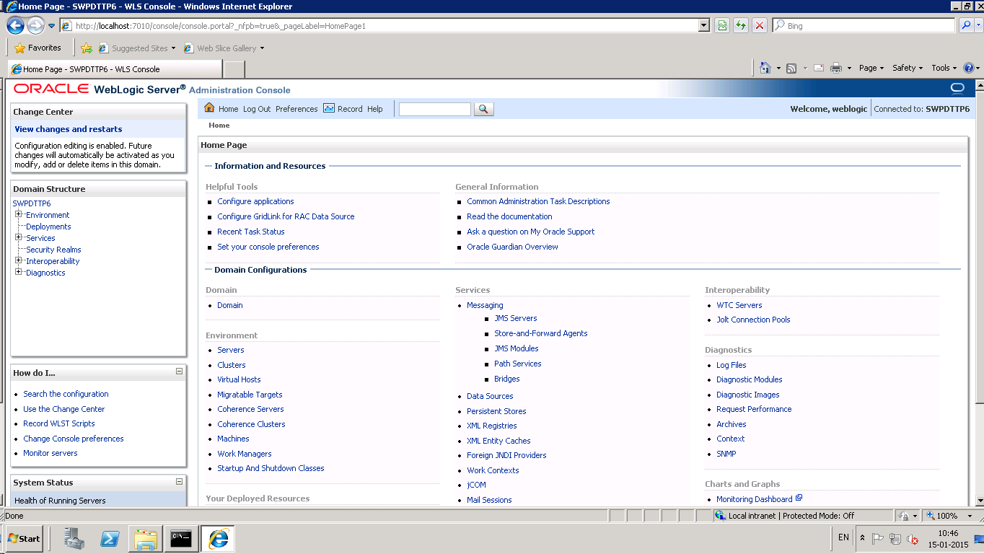

Click Data Sources

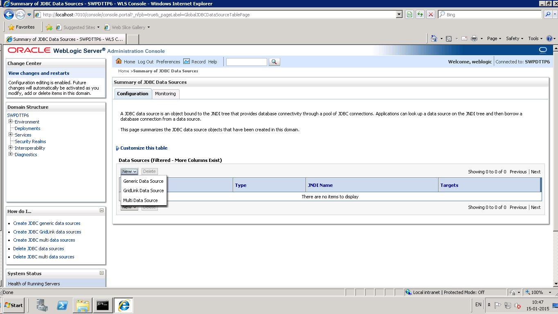

Click New and select Generic Data Source.

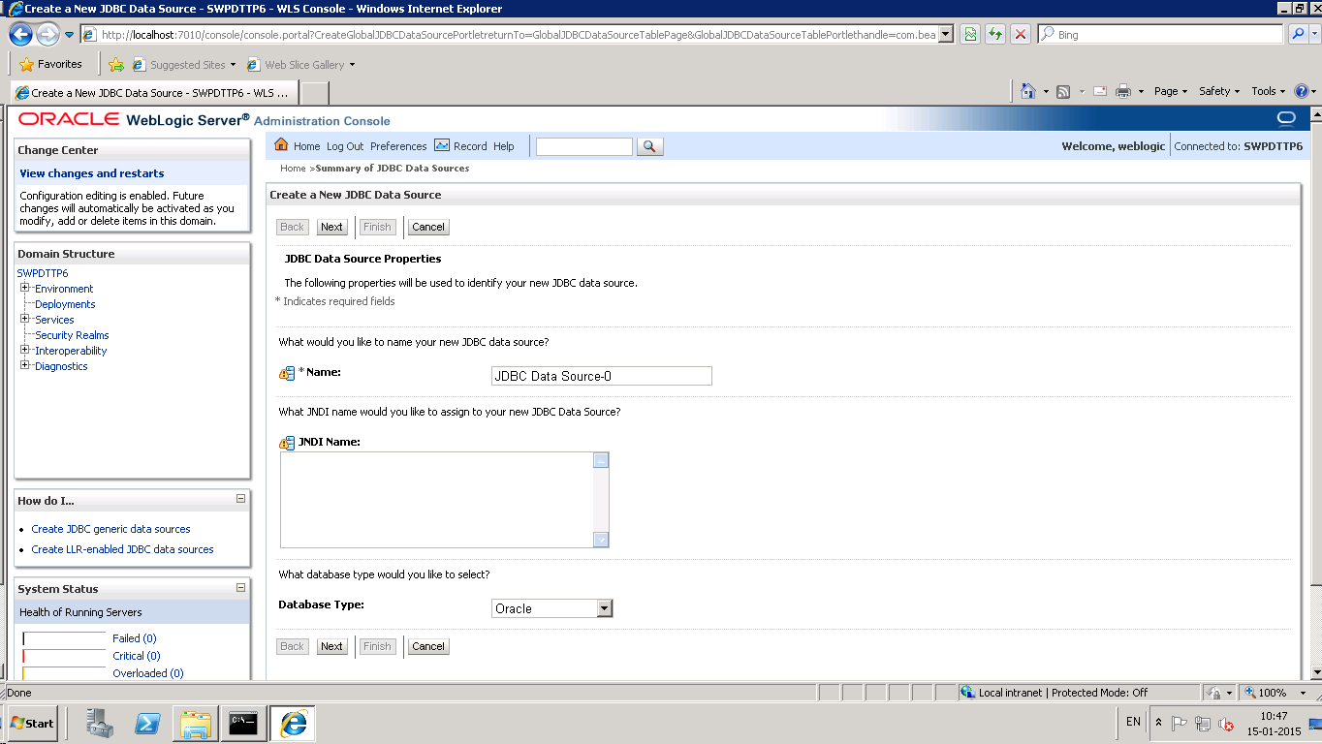

Edit Name field value as DTTConnectionDS and click Next.

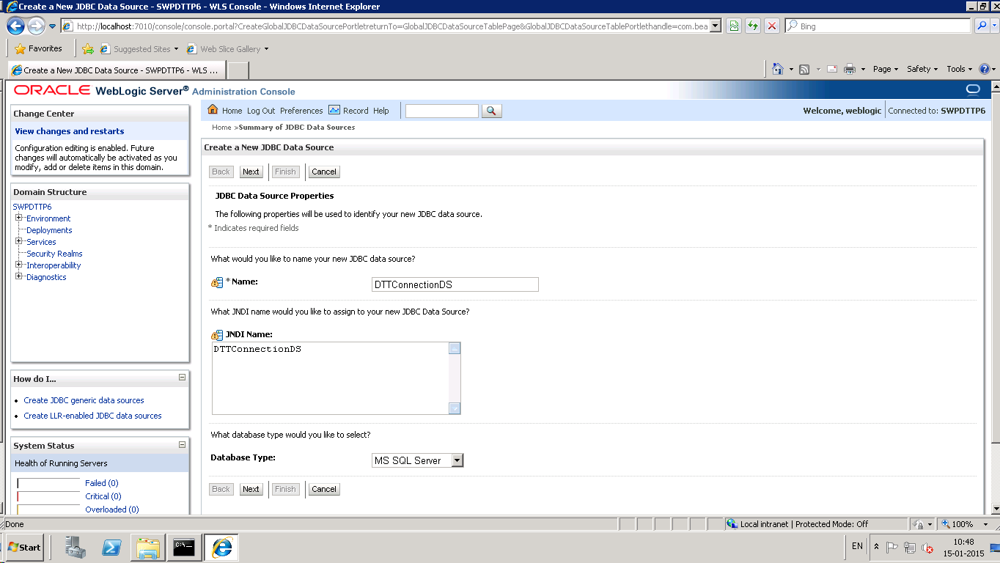

Select the MS SQL Driver and Click Next.

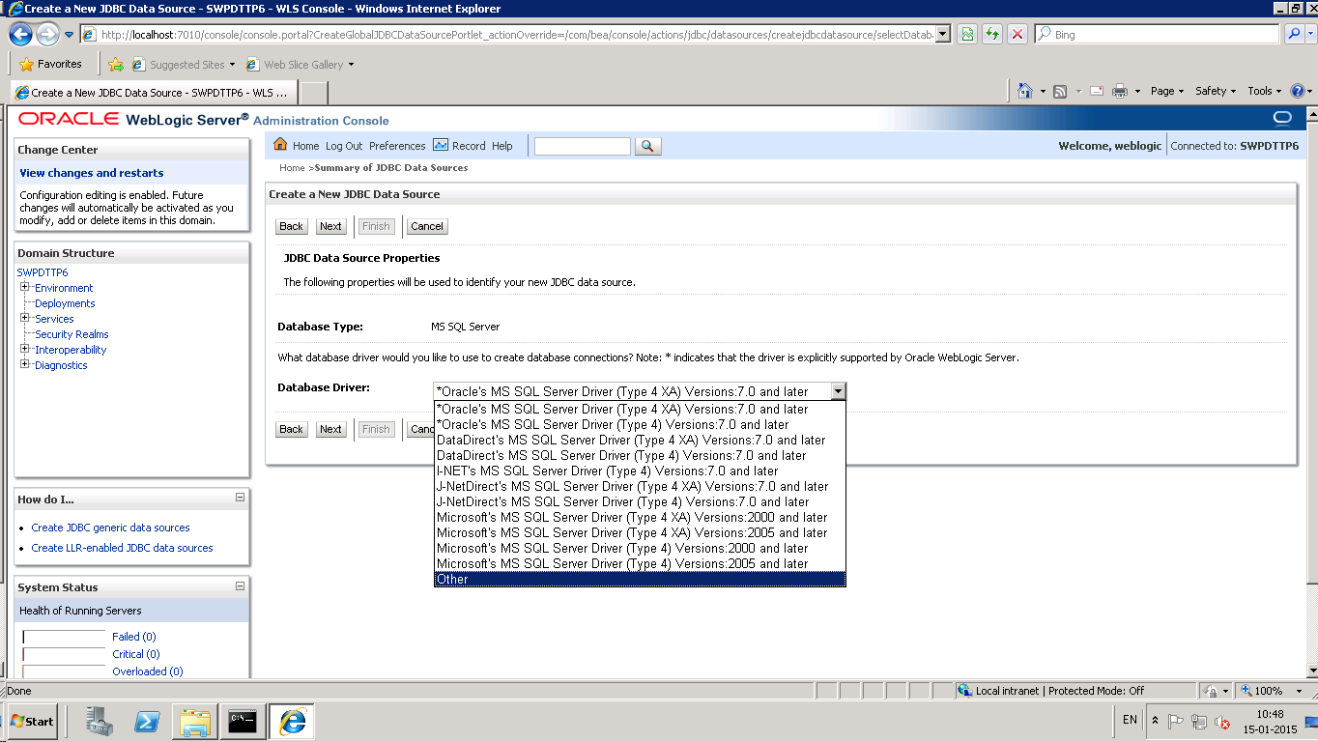

Select the Datasource properties as shown below:

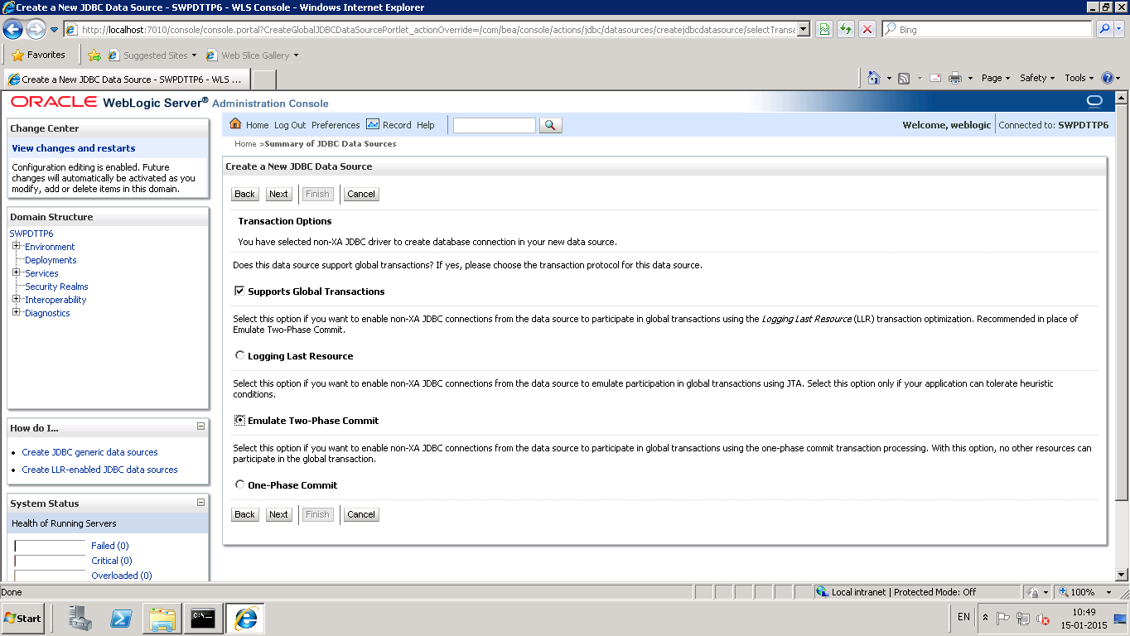

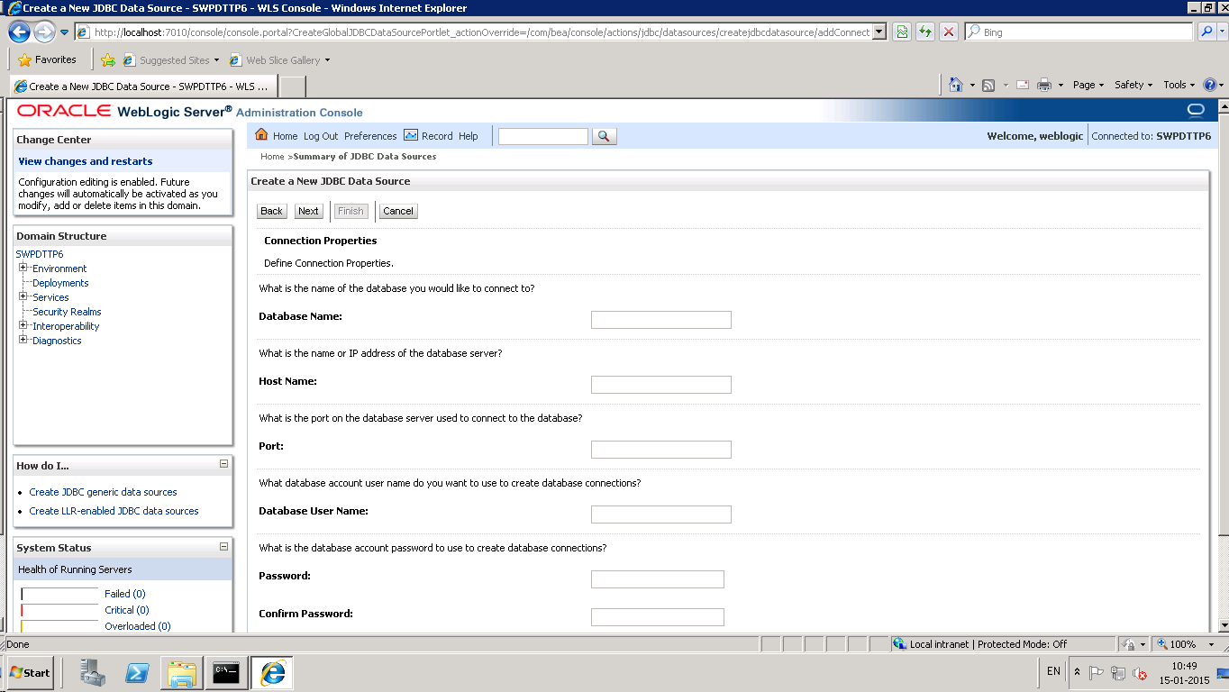

* URL= jdbc:weblogic:sqlserver://DKBDKB7DBS025A:1433
* DRIVER_CLASS_NAME= weblogic.jdbc.sqlserver.SQLServerDriver
* DB_USER_NAME=fltp_app_user
* DB_PASSWORD=1.fltpapp
* Properties: user=fltp_app_user
* portNumber=1433
* databaseName=FLTPDTTDB_EMEA
* serverName= DKBDKB7DBS025A

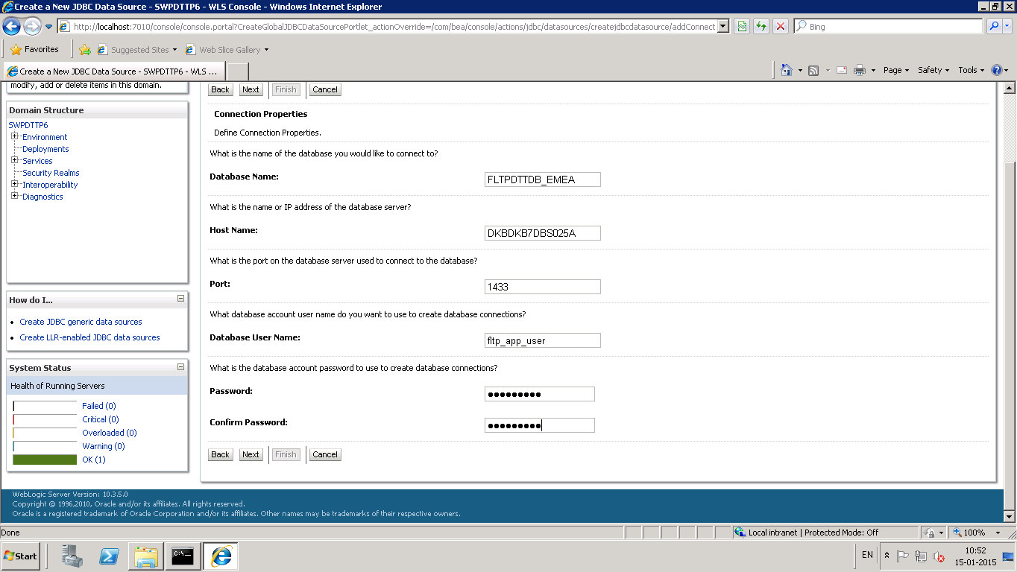

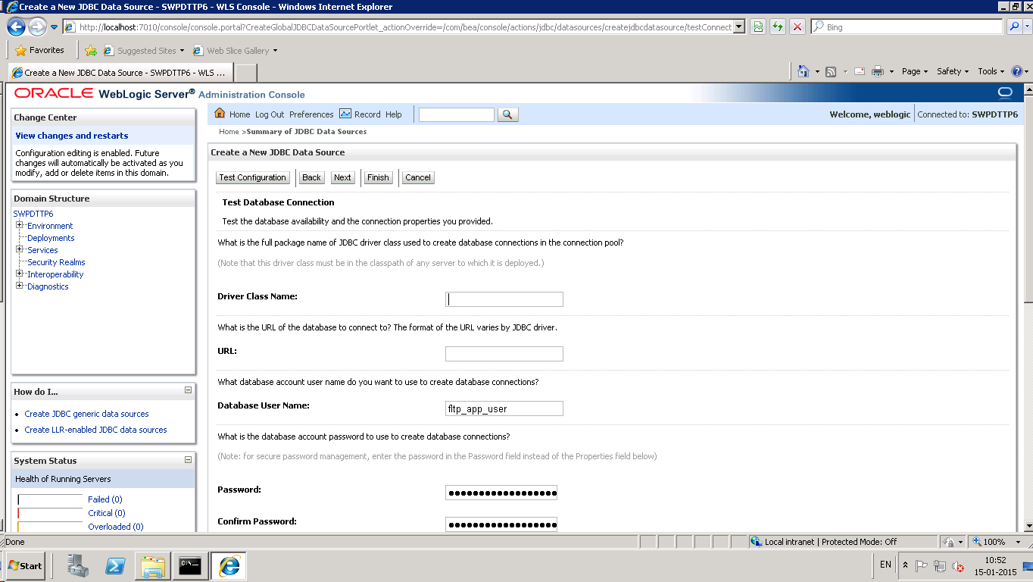

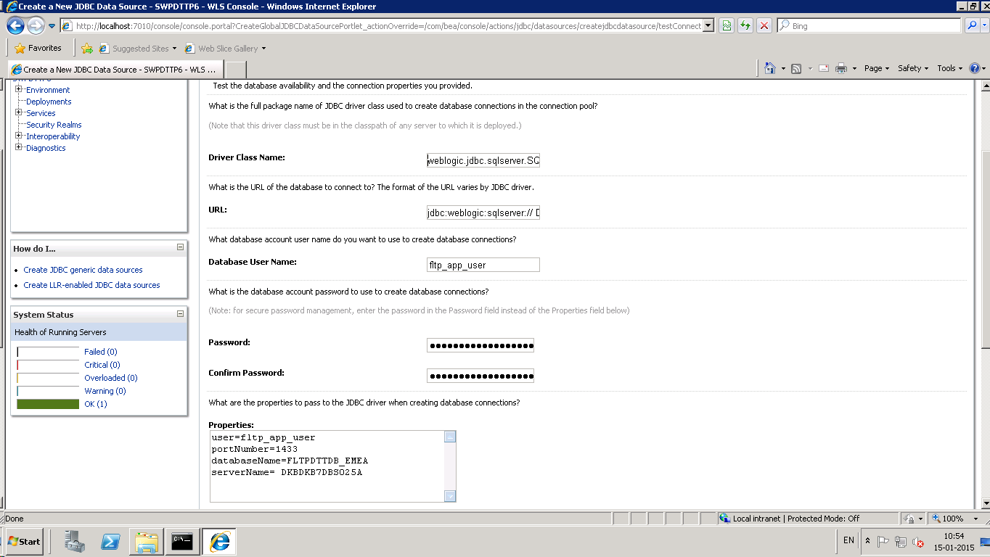

Select option Admin Server and Click Finish.

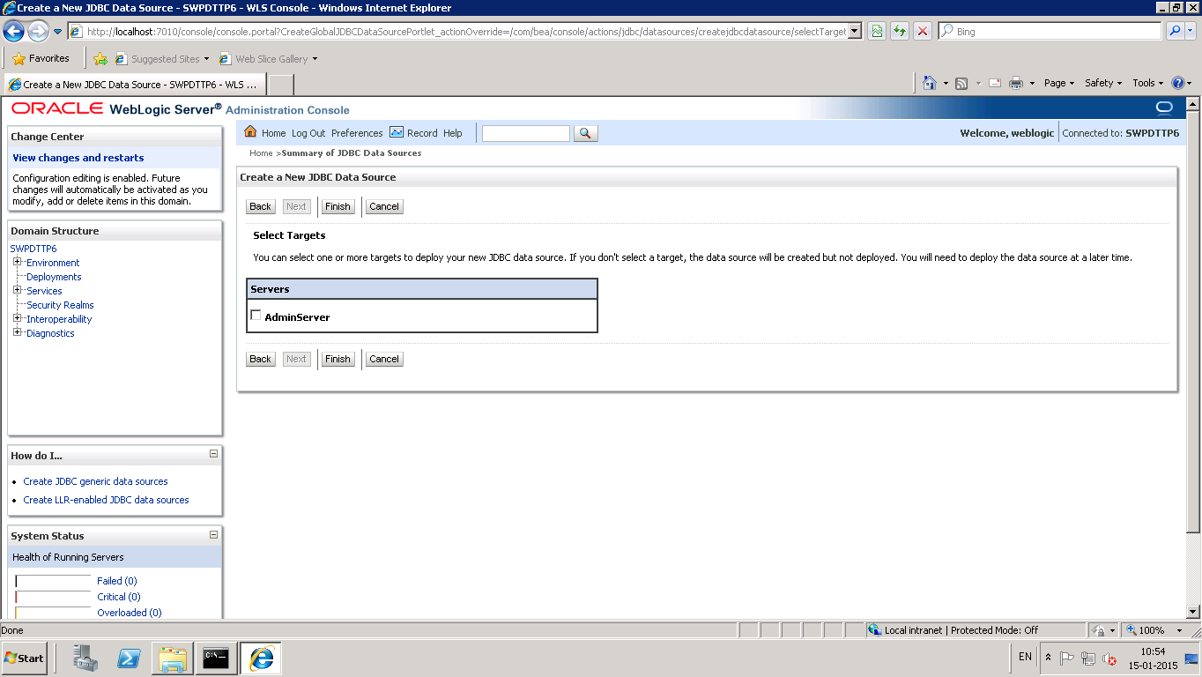

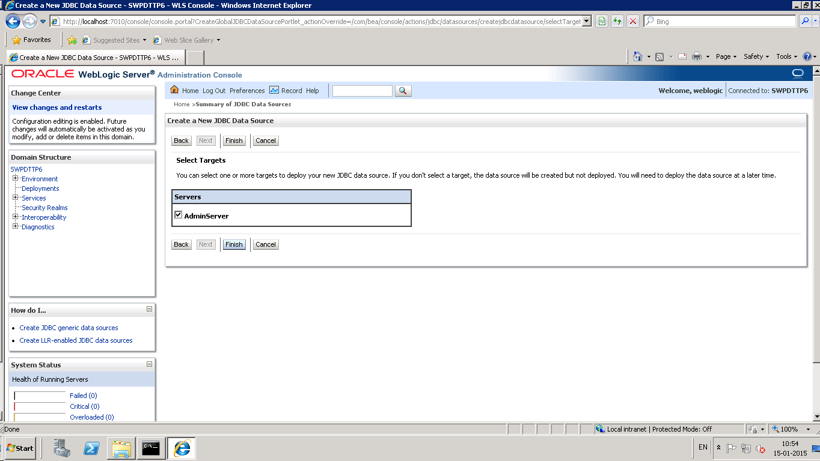

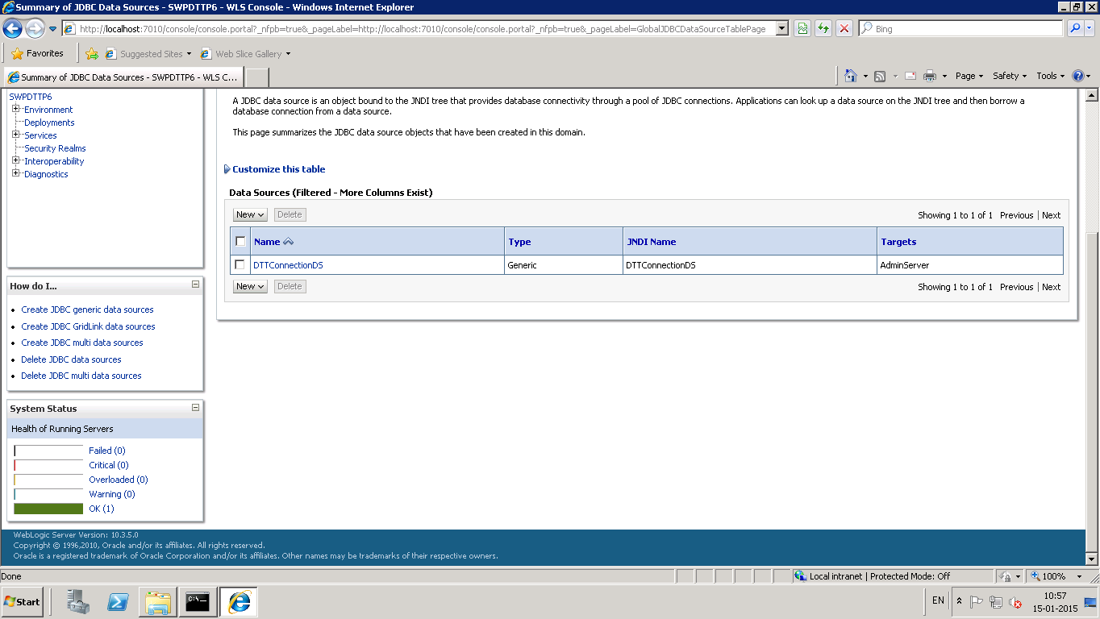

1. **Copy the ‘swpdttp6’ from Server location (Step2) to ‘D:\Oracle\Middleware\user_projects\domains\SWPDTTP6’ . If this step is successful then skip step 9.**
2. **Create folders and Transfer files:**
   1. Create folder ‘swpdttp6’ under ‘D:\Oracle\Middleware\user_projects\domains\SWPDTTP6’

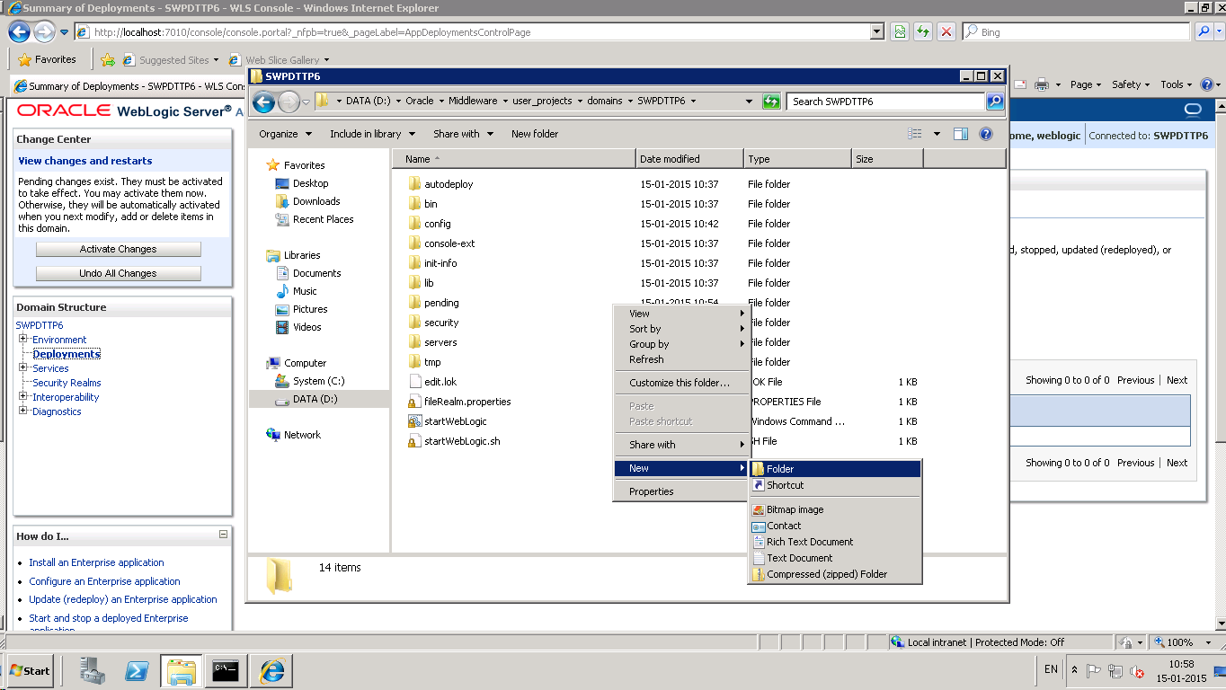

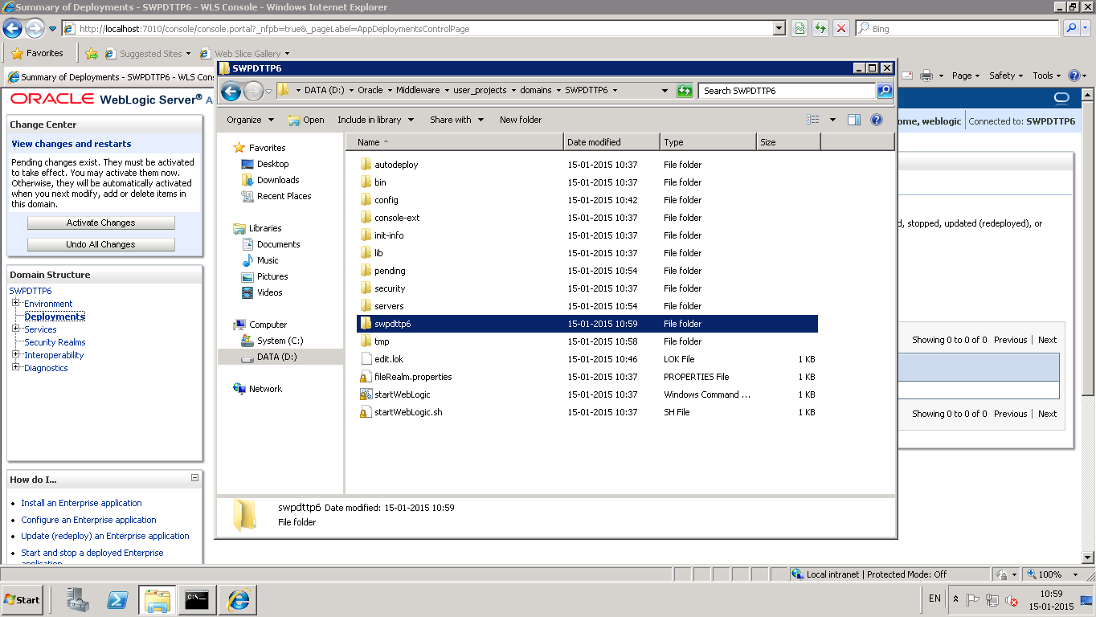

* 1. Create folder ‘dbscripts’,’ config’,’logs’ under ‘D:\Oracle\Middleware\user_projects\domains\SWPDTTP6\ swpdttp6’

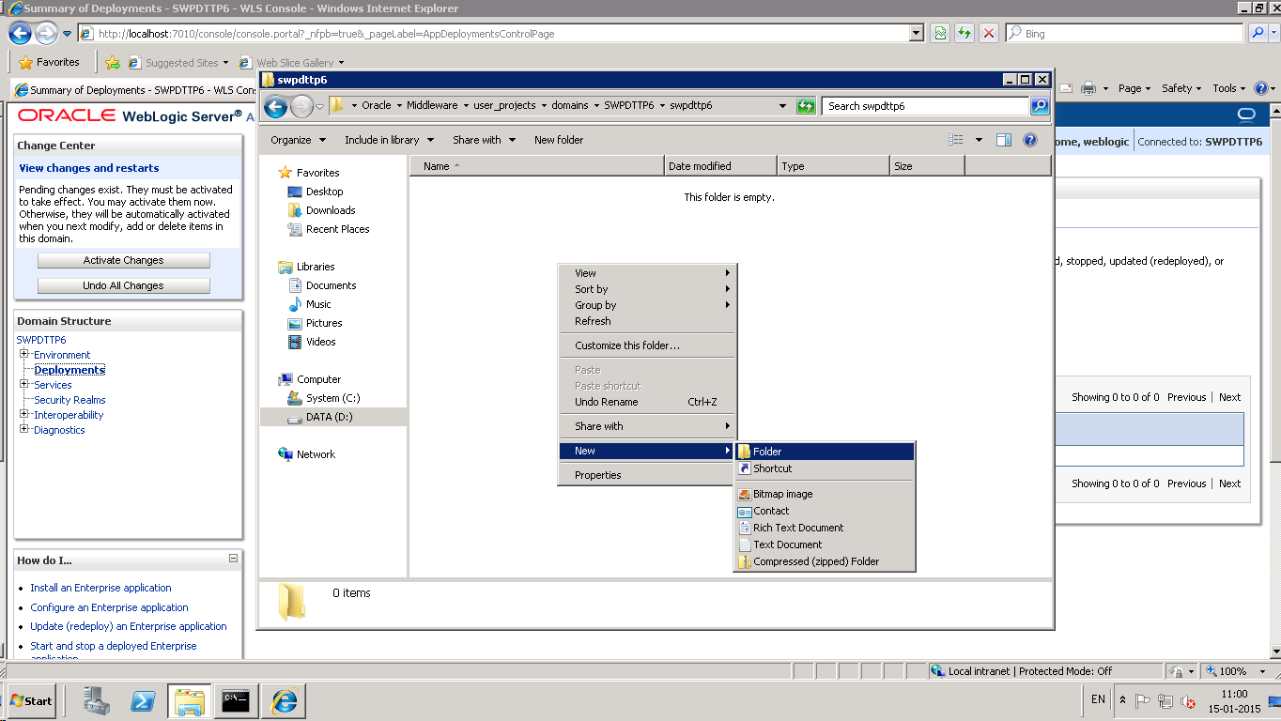

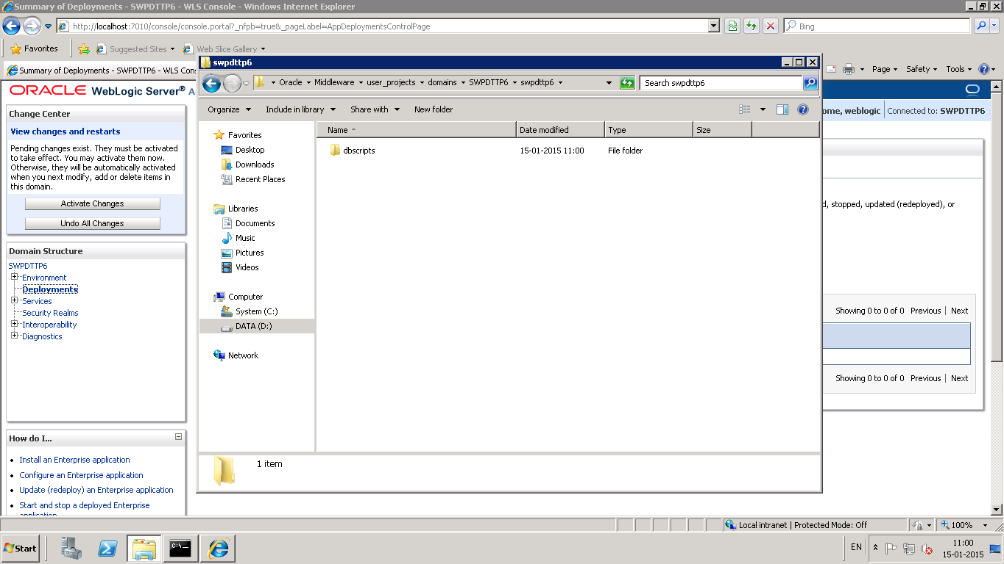

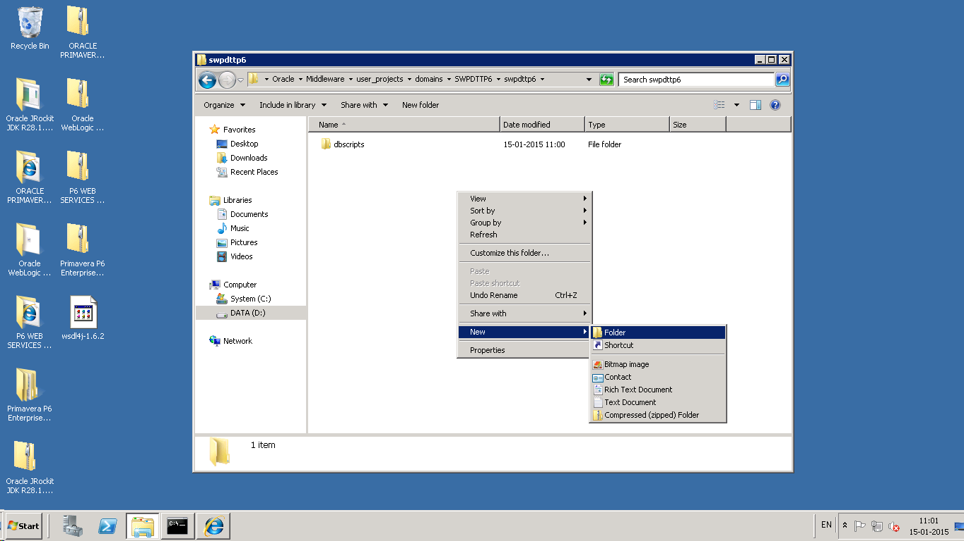

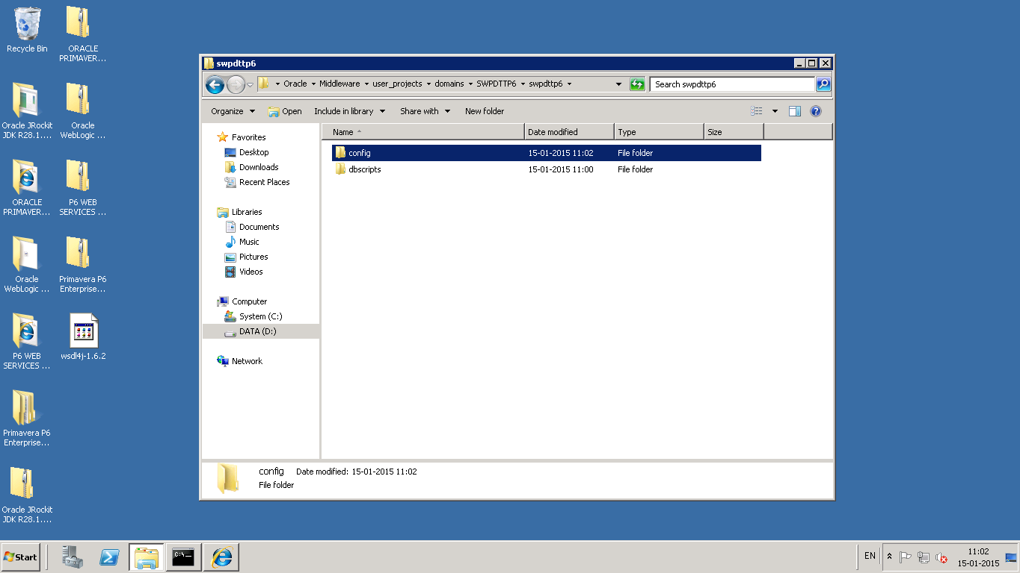

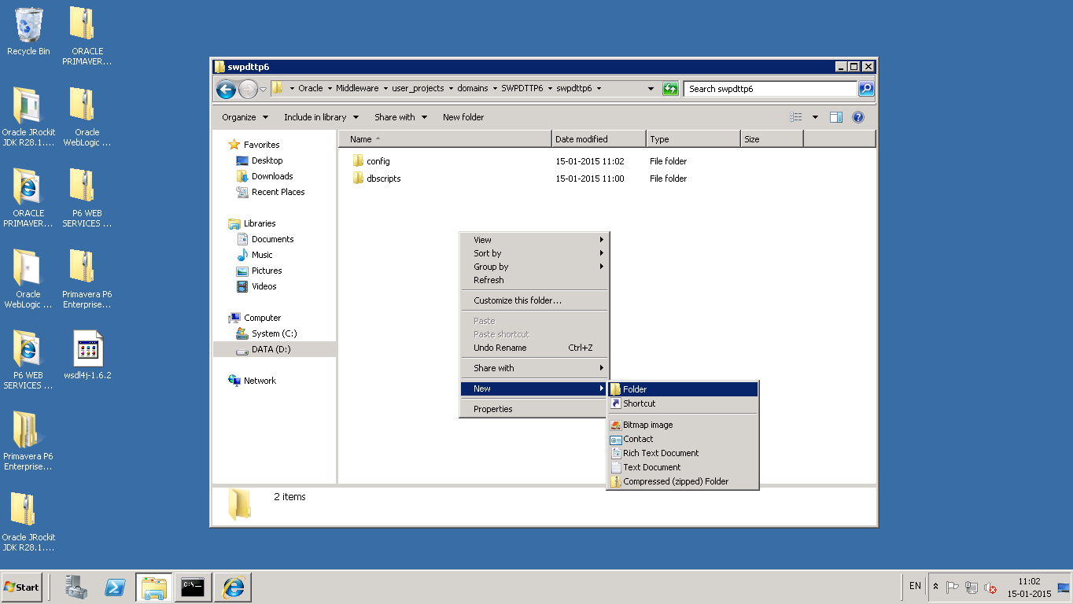

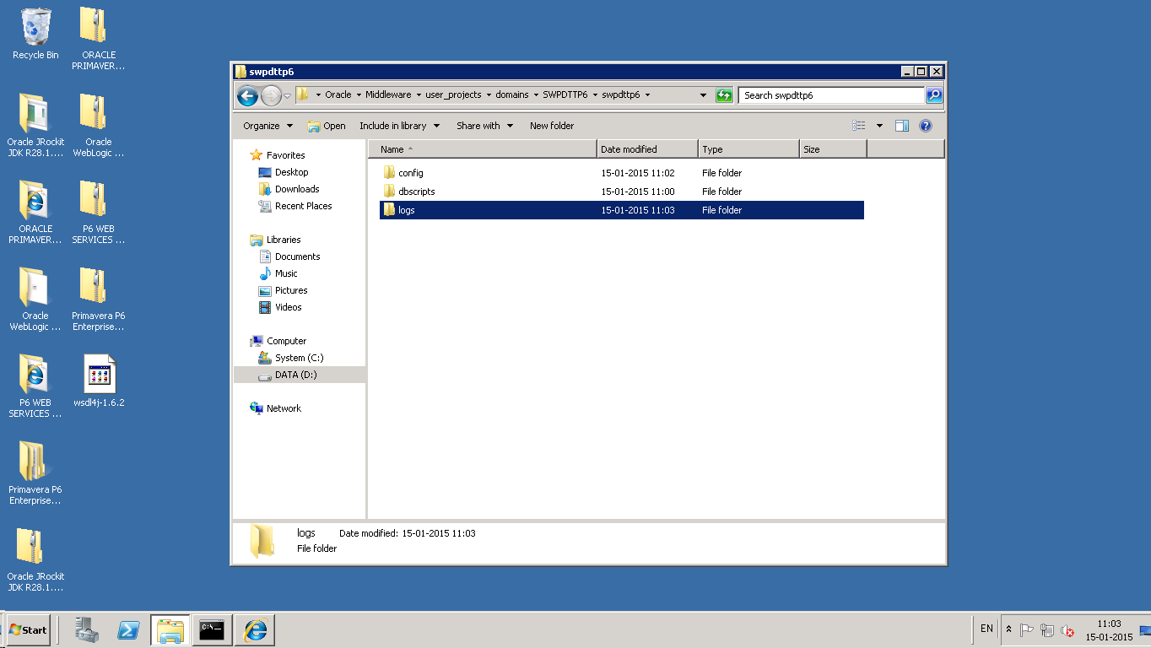

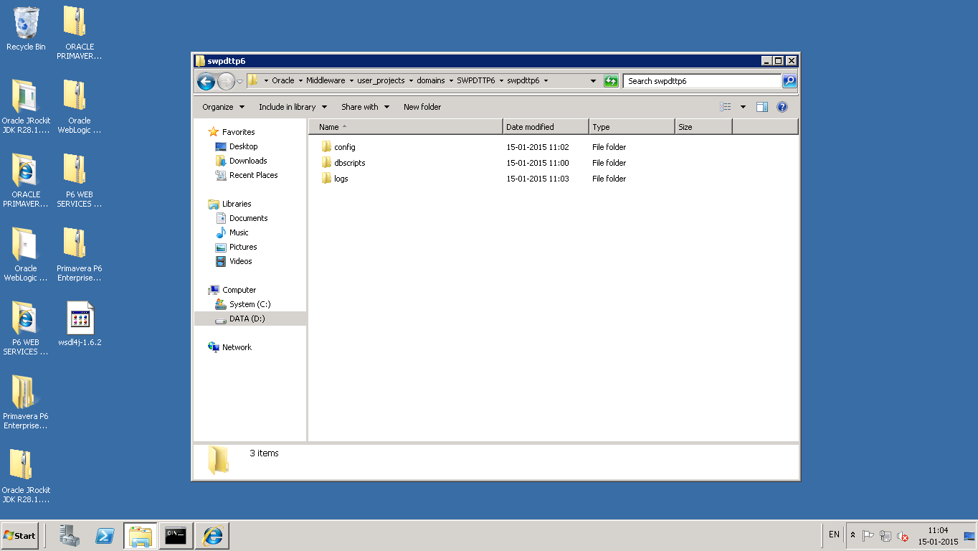

* 1. Transfer SWPDTTP6.war file to server folder location ‘D:\Oracle\Middleware\user_projects\domains\SWPDTTP6\swpdttp6\’

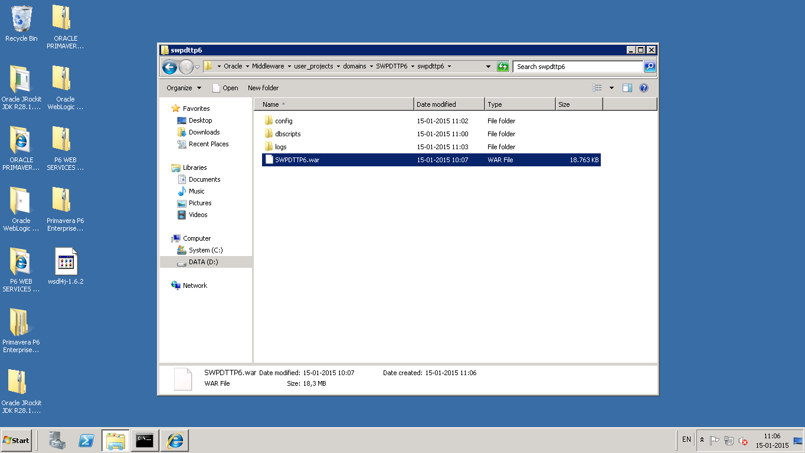

* 1. Transfer database scripts file ‘DTTScripts.sql’ to server folder location D:\Oracle\Middleware\user_projects\domains\ SWPDTTP6\swpdttp6\dbscripts\
  2. Transfer DTT.properties to server folder location D:\Oracle\Middleware\user_projects\domains\ SWPDTTP6\swpdttp6\config\

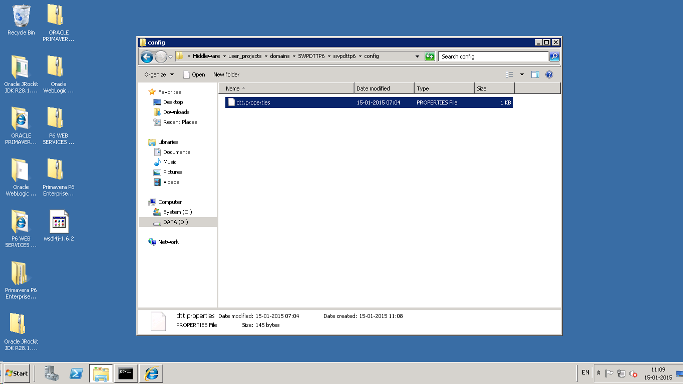

1. **Create a Windows Scheduled Task**

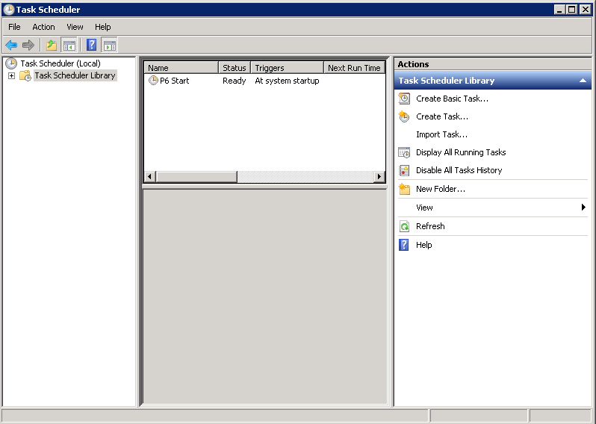

Go to Task Scheduler, Click Create Task

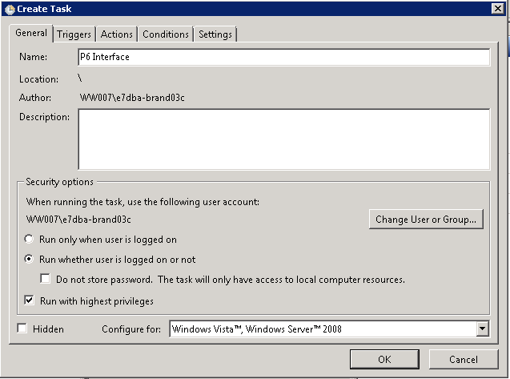

Select ‘Change User or Group’ and change the user to E7DBS-FLTP_P6_Serv

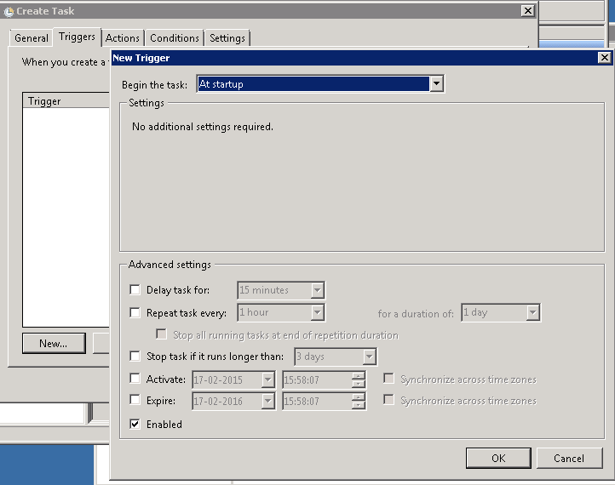

Select the trigger tab and add new

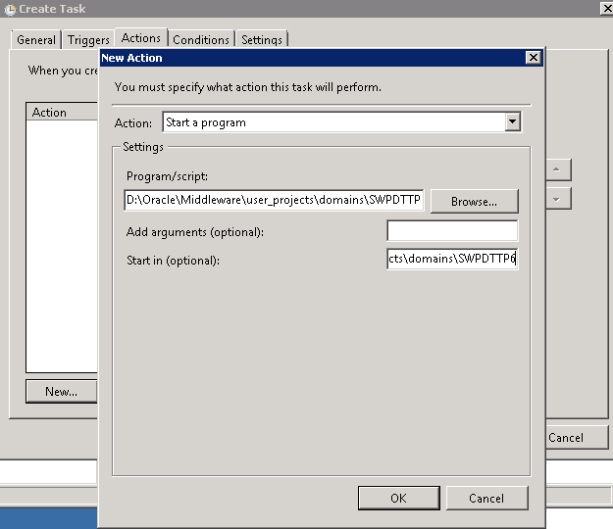

Select the Action tab and create new

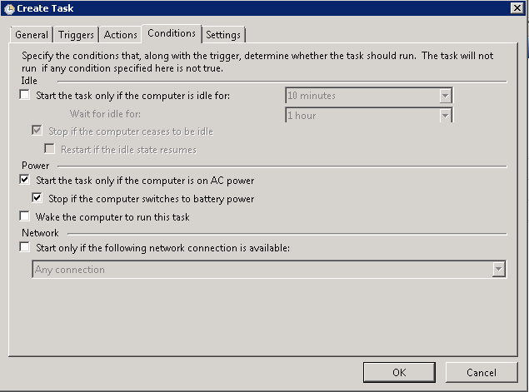

Modify the condition tab

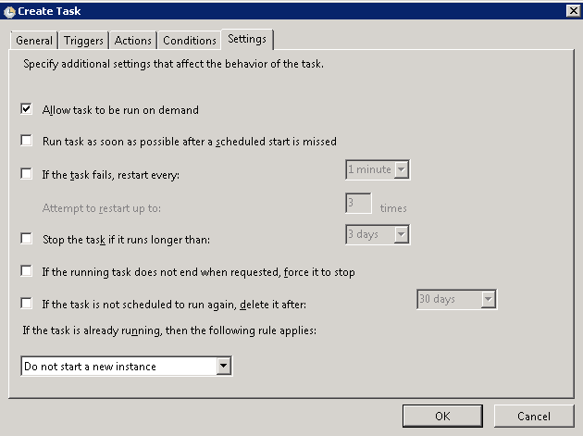

Modify Setting tab and press ok

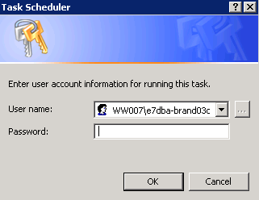

Type in the user for the running the task

1. **Edit the DTT.properties with the changes required as follows:**

* PRIMAVERA_WEBSERVICE_SERVER= **DKBDKB7APP051A**
* WEBSERVICE_USERNAME=E7DBS-FLPT_P6_Int
* WEBSERVICE_PASSWORD=<<See password repository>>
* WEBSERVICE_PORT=8206
* JNDINAME= DTTConnectionDS

1. **Deploy the SWPDTTP6.war using weblogic console**

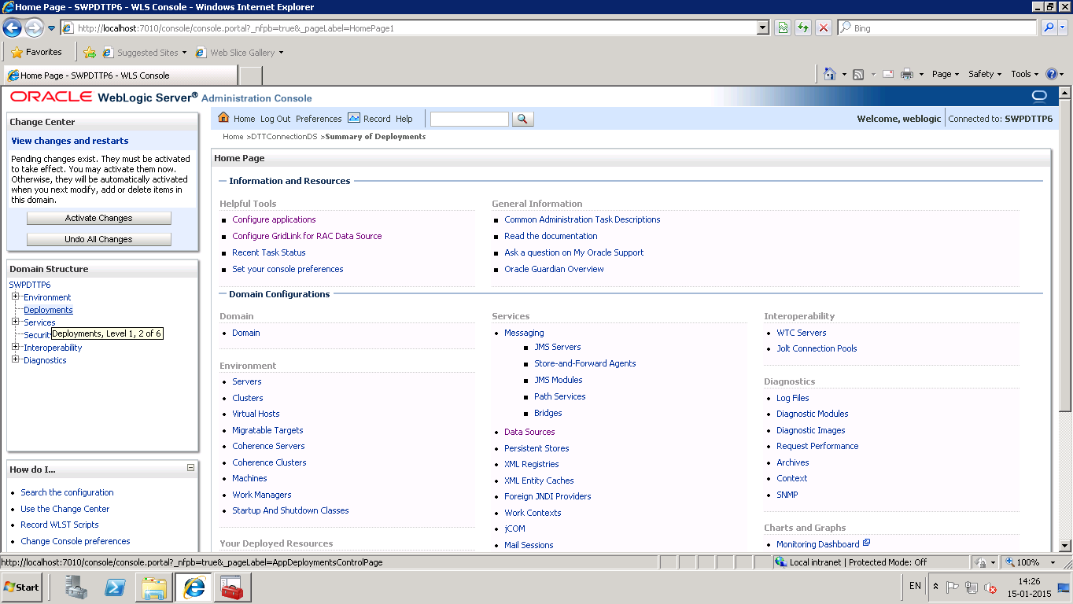

Click Deployments link

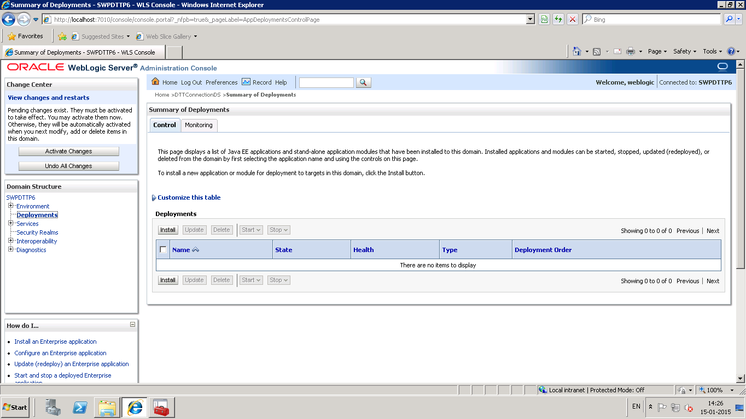

Create new deployment by clicking Install.

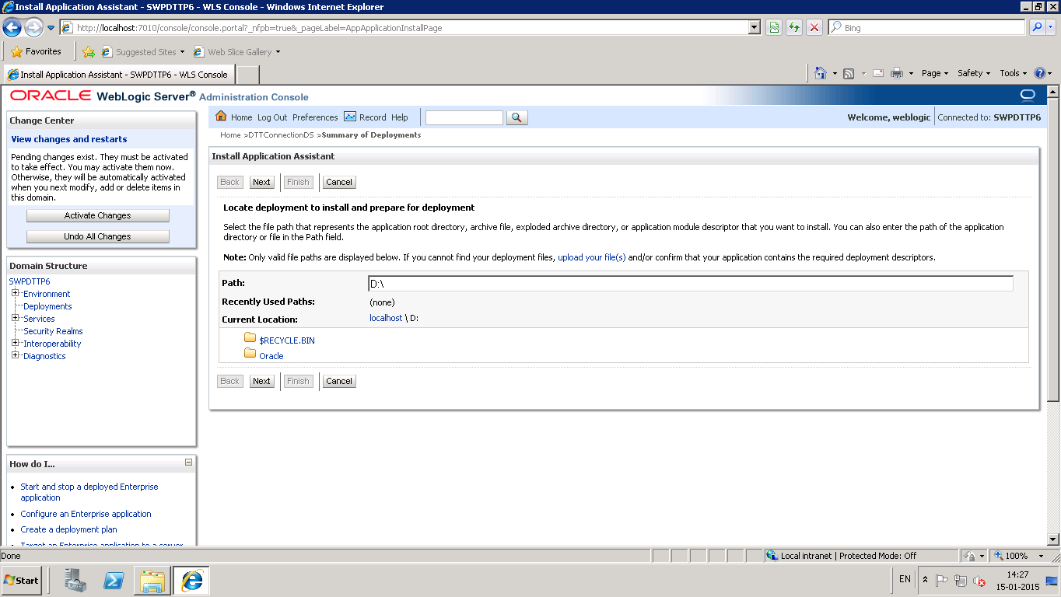

Click Browse and Select the war file ‘SWPDTTP6.war’ under D:\Oracle\Middleware\user_projects\domains\ SWPDTTP6\swpdttp6\

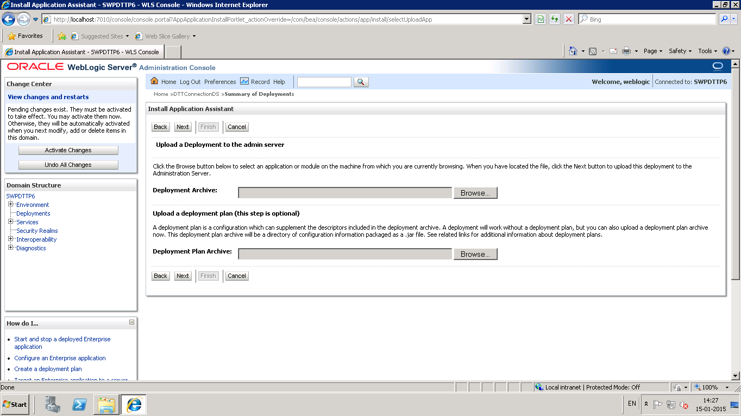

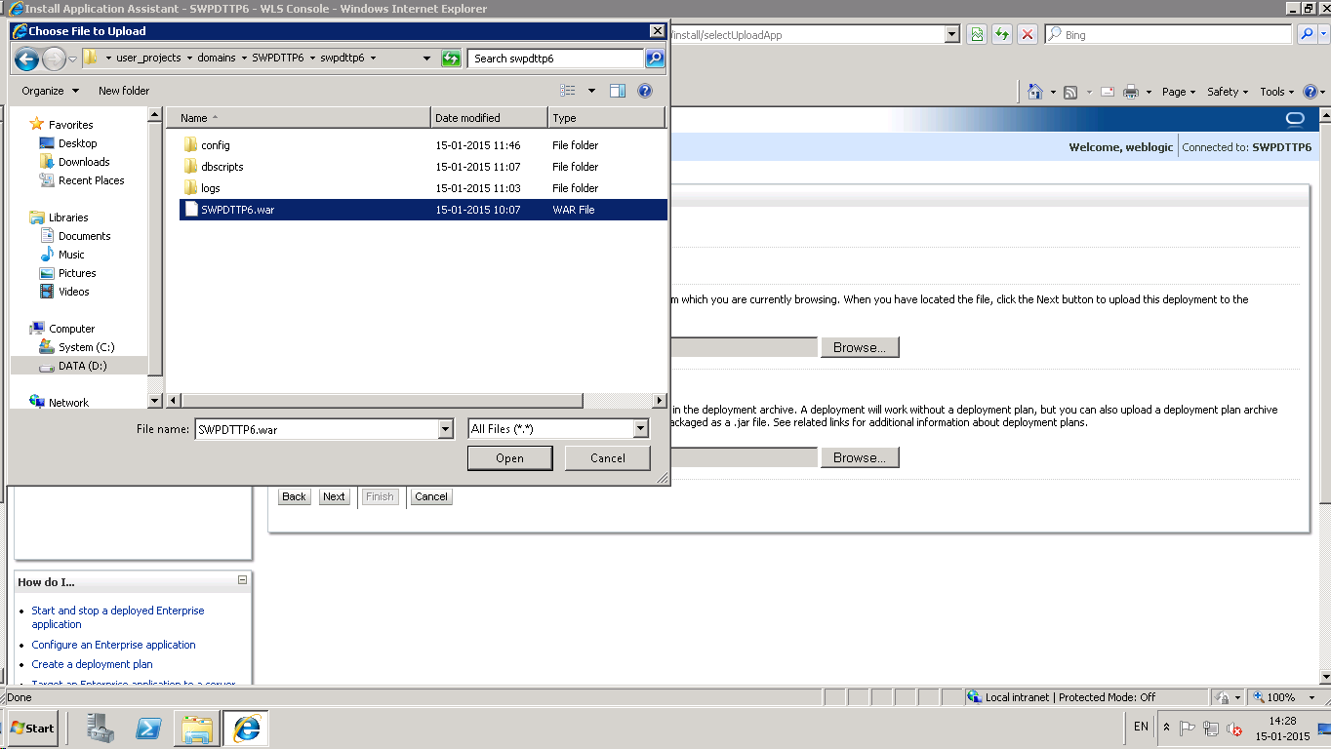

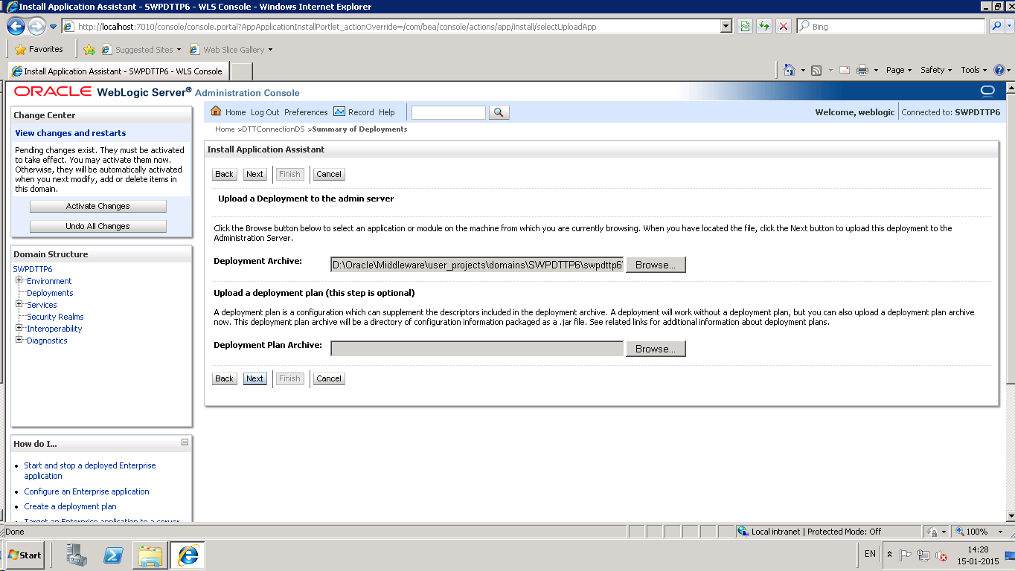

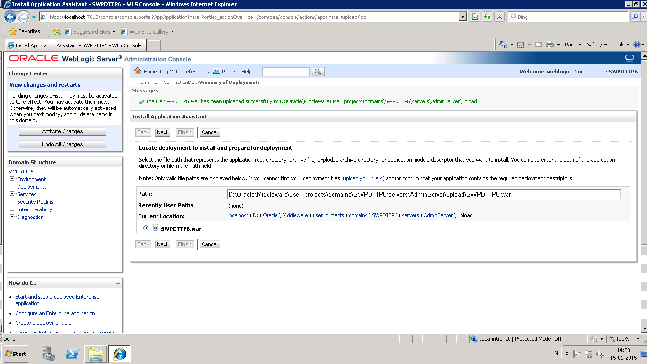

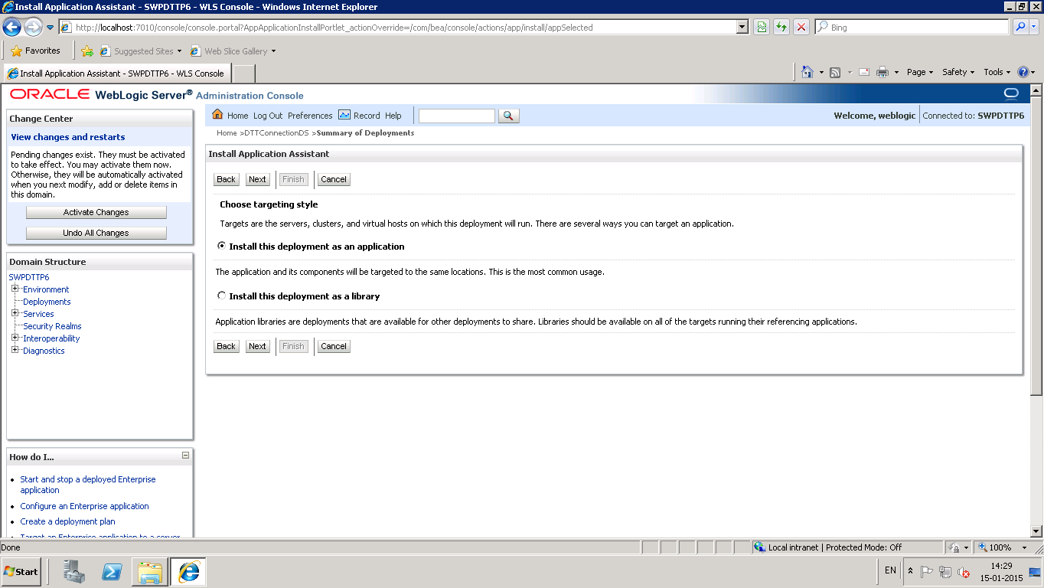

Click Next.

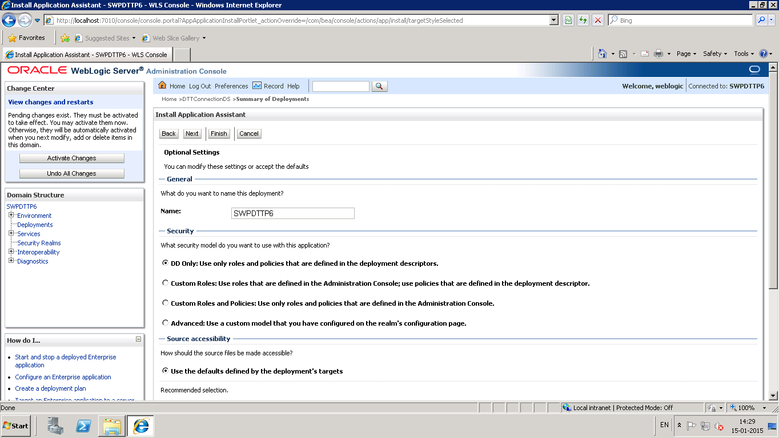

Click Next.

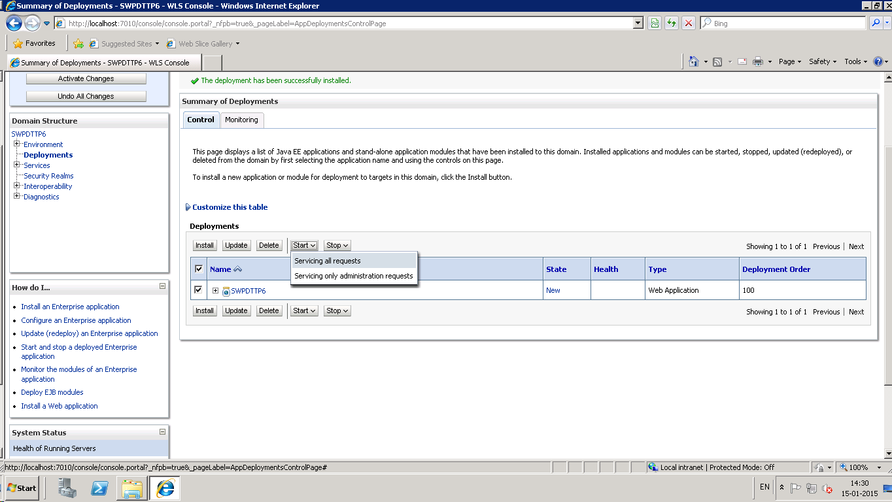

1. **Open the log file at location 'D:\Oracle\Middleware\user_projects\domains\ SWPDTTP6\swpdttp6\logs\swpdttp6.log'**
2. **Transfer the input excel data file received by Business to the location D:\Oracle\Middleware\user_projects\domains\ SWPDTTP6\swpdttp6\config\**
3. **Undeploy and Redeploy the SWPDTTP6.war (follow step 16)**
4. **Open the log file at location 'D:\Oracle\Middleware\user_projects\domains\ SWPDTTP6\swpdttp6\logs\swpdttp6.log' ,it should start logging FLTP Solution messages.**